**Below steps are followed to build the heart attack prediction model**

**Tools used**

**Sagemaker Notebook instance**

An Amazon SageMaker notebook instance is a machine learning (ML) compute instance running the Jupyter Notebook App. SageMaker manages creating the instance and related resources. Use Jupyter notebooks in your notebook instance to prepare and process data, write code to train models, deploy models to SageMaker hosting, and test or validate your models

**Amazon S3 bucket**

Amazon Simple Storage Service (Amazon S3) is an object storage service that offers industry-leading scalability, data availability, security, and performance. Amazon S3 provides easy-to-use management features so you can organize your data and configure finely-tuned access controls to meet your specific business, organizational, and compliance requirements. Amazon S3 is designed for 99.999999999% (11 9's) of durability, and stores data for millions of applications for companies all around the world.

Store your data in Amazon S3 and secure it from unauthorized access with encryption features and access management tools. S3 is the only object storage service that allows you to block public access to all of your objects at the bucket or the account level with [S3 Block Public Access](https://aws.amazon.com/s3/features/block-public-access/).

**AWS Lambda function**

AWS Lambda is a serverless compute service that lets you run code without provisioning or managing servers, creating workload-aware cluster scaling logic, maintaining event integrations, or managing runtimes. With Lambda, you can run code for virtually any type of application or backend service - all with zero administration. Just upload your code as a ZIP file or container image, and Lambda automatically and precisely allocates compute execution power and runs your code based on the incoming request or event, for any scale of traffic.

**Application programming interface** (**API**) is an interface that defines interactions between multiple software applications or mixed hardware-software intermediaries.[1] It defines the kinds of calls or requests that can be made, how to make them, the data formats that should be used, the conventions to follow, etc. It can also provide extension mechanisms so that users can extend existing functionality in various ways and to varying degrees.

A **REST API** (also known as RESTful API) is an application programming interface (API or web API) that conforms to the constraints of REST architectural style and allows for interaction with RESTful web services.

**Model Used**

**Naïve Bayes Classifiers(Most Efficient)**

**Naive Bayes classifiers** are a family of simple "[probabilistic classifiers](https://en.wikipedia.org/wiki/Probabilistic_classification)" based on applying [Bayes' theorem](https://en.wikipedia.org/wiki/Bayes%27_theorem) with strong (naïve) [independence](https://en.wikipedia.org/wiki/Statistical_independence) assumptions between the features (see [Bayes classifier](https://en.wikipedia.org/wiki/Bayes_classifier)). They are among the simplest [Bayesian network](https://en.wikipedia.org/wiki/Bayesian_network) models,[[1]](https://en.wikipedia.org/wiki/Naive_Bayes_classifier#cite_note-1) but coupled with [kernel density estimation](https://en.wikipedia.org/wiki/Kernel_density_estimation), they can achieve higher accuracy levels.[[2]](https://en.wikipedia.org/wiki/Naive_Bayes_classifier#cite_note-piryonesi2020-2)[[3]](https://en.wikipedia.org/wiki/Naive_Bayes_classifier#cite_note-hastie01-3)

Naive Bayes is a simple technique for constructing classifiers: models that assign class labels to problem instances, represented as vectors of [feature](https://en.wikipedia.org/wiki/Feature_vector) values, where the class labels are drawn from some finite set. There is not a single [algorithm](https://en.wikipedia.org/wiki/Algorithm) for training such classifiers, but a family of algorithms based on a common principle: all naive Bayes classifiers assume that the value of a particular feature is [independent](https://en.wikipedia.org/wiki/Independence_(probability_theory)) of the value of any other feature, given the class variable. For some types of probability models, naive Bayes classifiers can be trained very efficiently in a [supervised learning](https://en.wikipedia.org/wiki/Supervised_learning) setting. In many practical applications, parameter estimation for naive Bayes models uses the method of [maximum likelihood](https://en.wikipedia.org/wiki/Maximum_likelihood). Despite their naive design and apparently oversimplified assumptions, naive Bayes classifiers have worked quite well in many complex real-world situations.

An advantage of naive Bayes is that it only requires a small number of training data to estimate the parameters necessary for classification.

**Other models are described later in the report**.

Neural Net

LogisticRegression

KNN

SVC

DecisionTree

RandomForest

GradientBoost

AdaBoost

XGB

**Architecture**

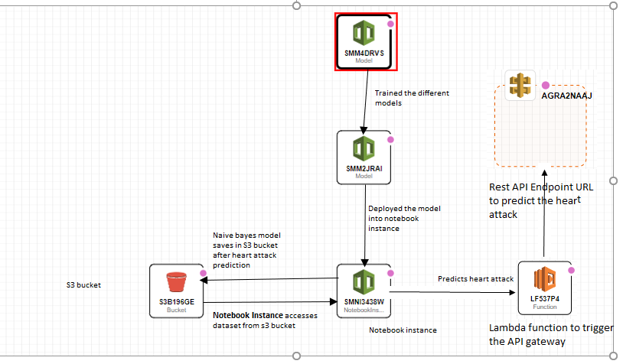

To keep the dataset safe and secure as it contains personal data, we have used S3 bucket.

1. **Creation of S3 bucket**



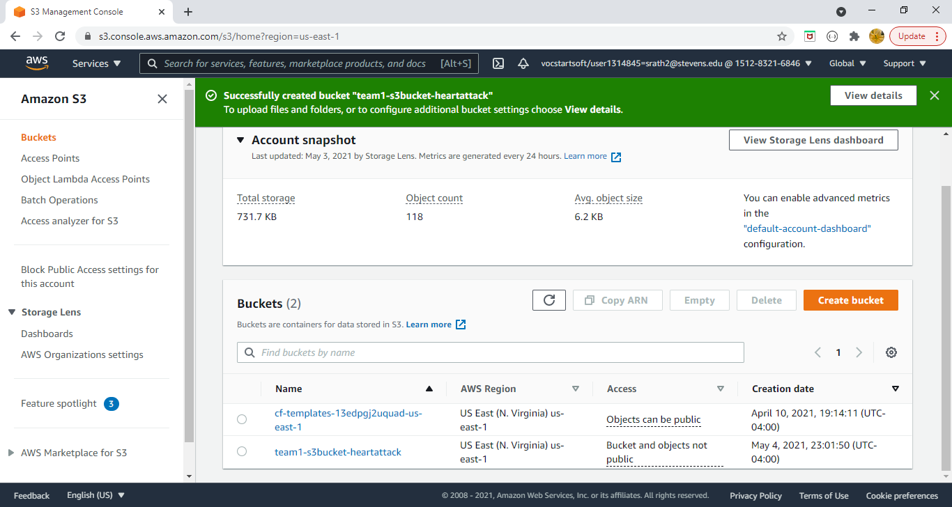

1. **After the creation of S3 bucket, dataset which will be used for heart attack prediction is uploaded to the S3 bucket.**

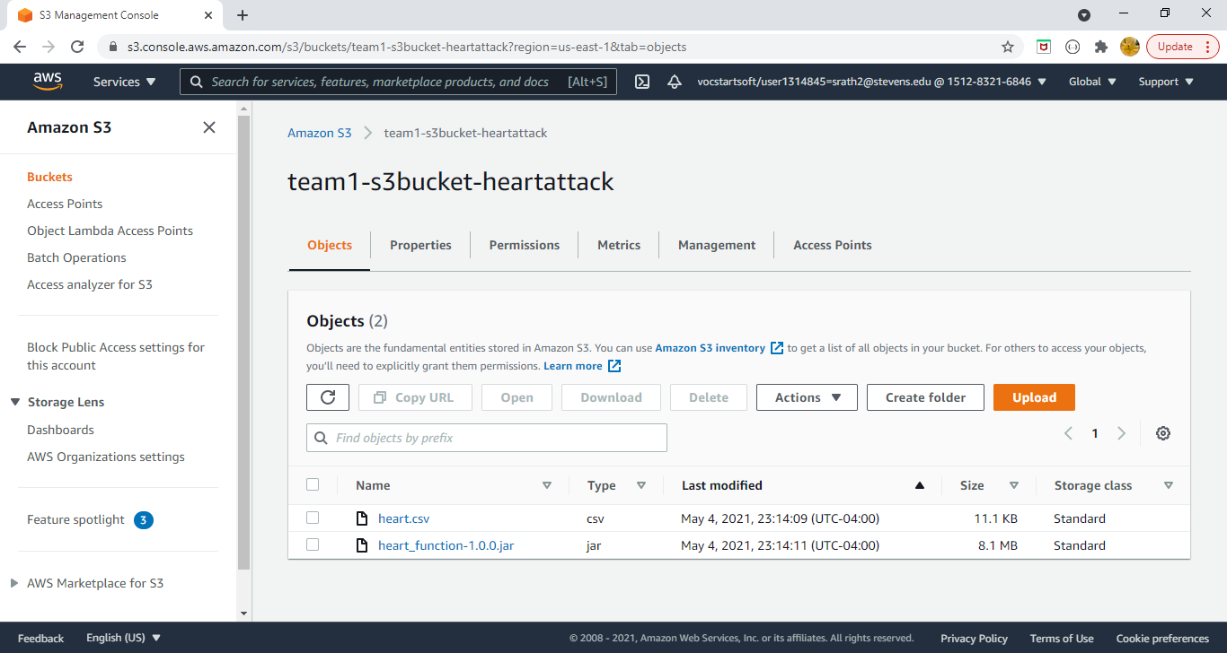

1. **Once the creation is done, we have created Notebook instance provided by Amazon SageMaker studio which will allow us to train and deploy the models.**

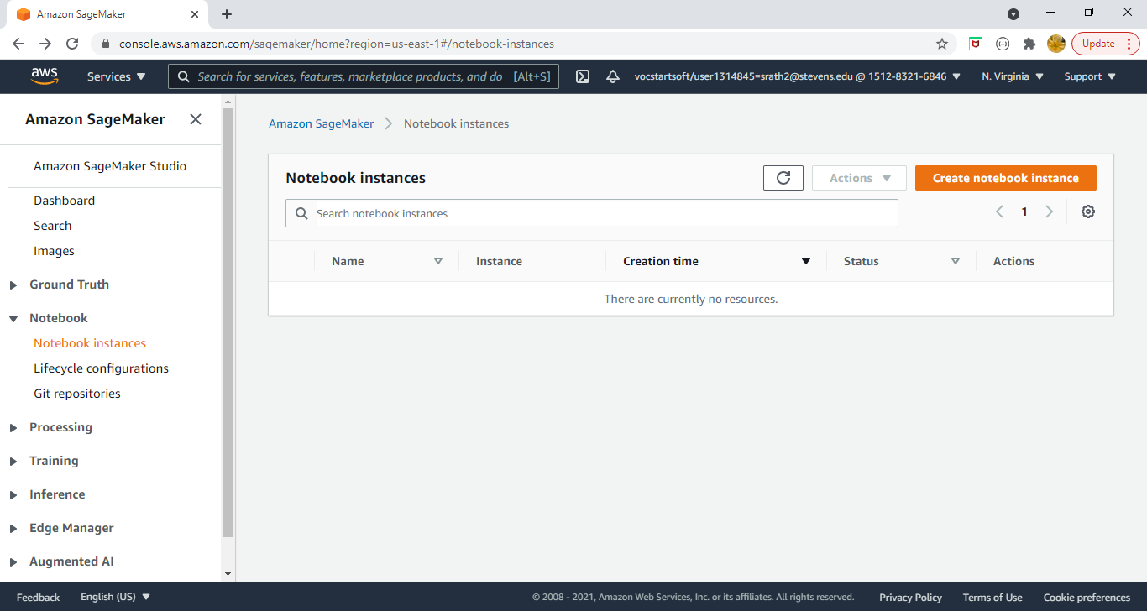

1. **We have used ml.t2.medium instance type which is used for the creation of notebook instance type**

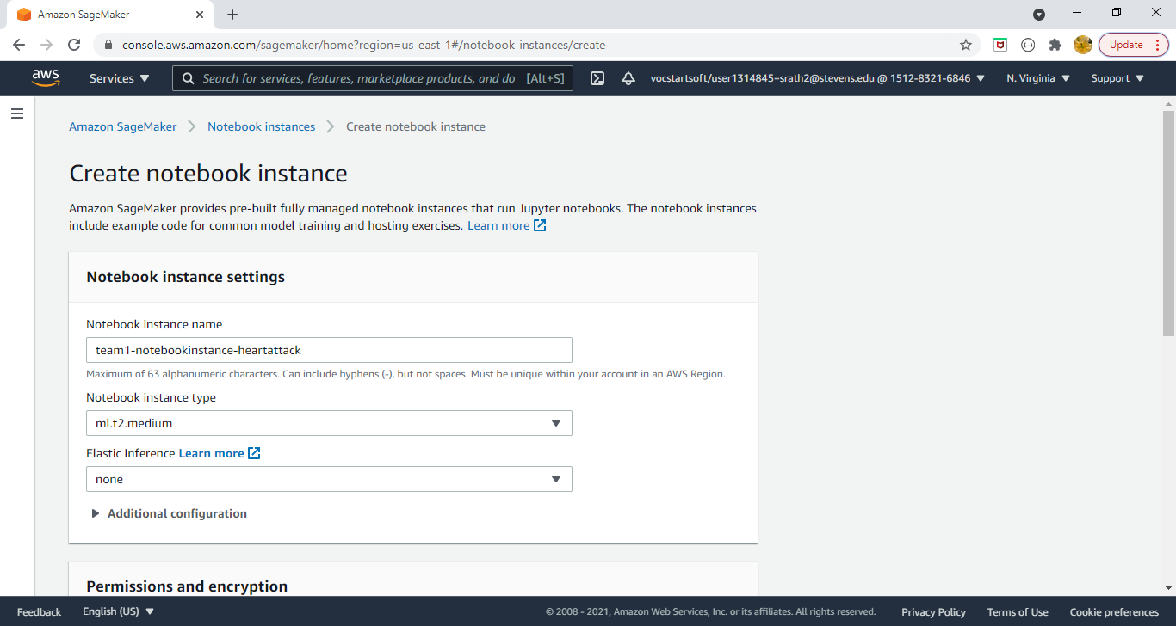

1. **We have created a new IAM role and provided the S3 bucket name which we have created earlier so that the notebook instance can access the data from S3 bucket.**

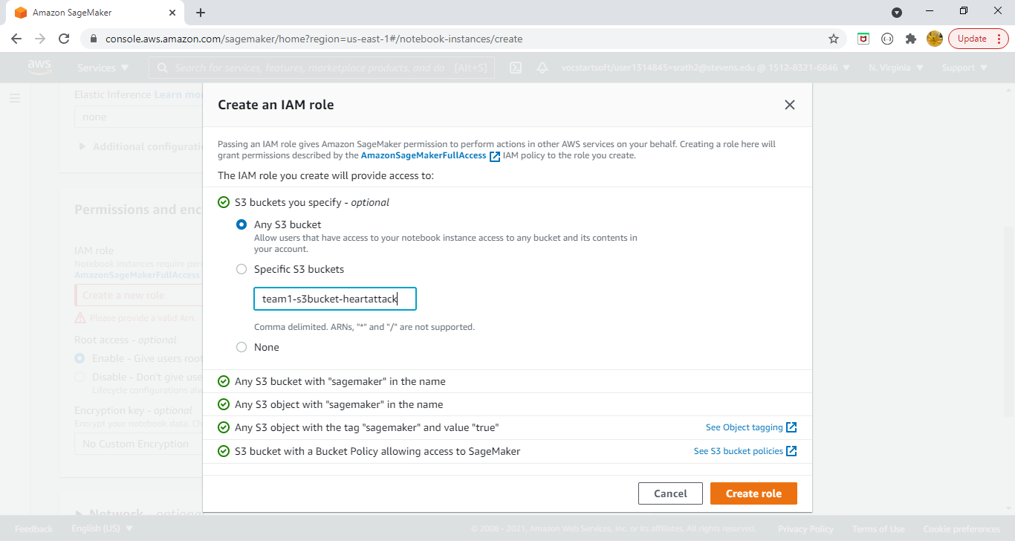

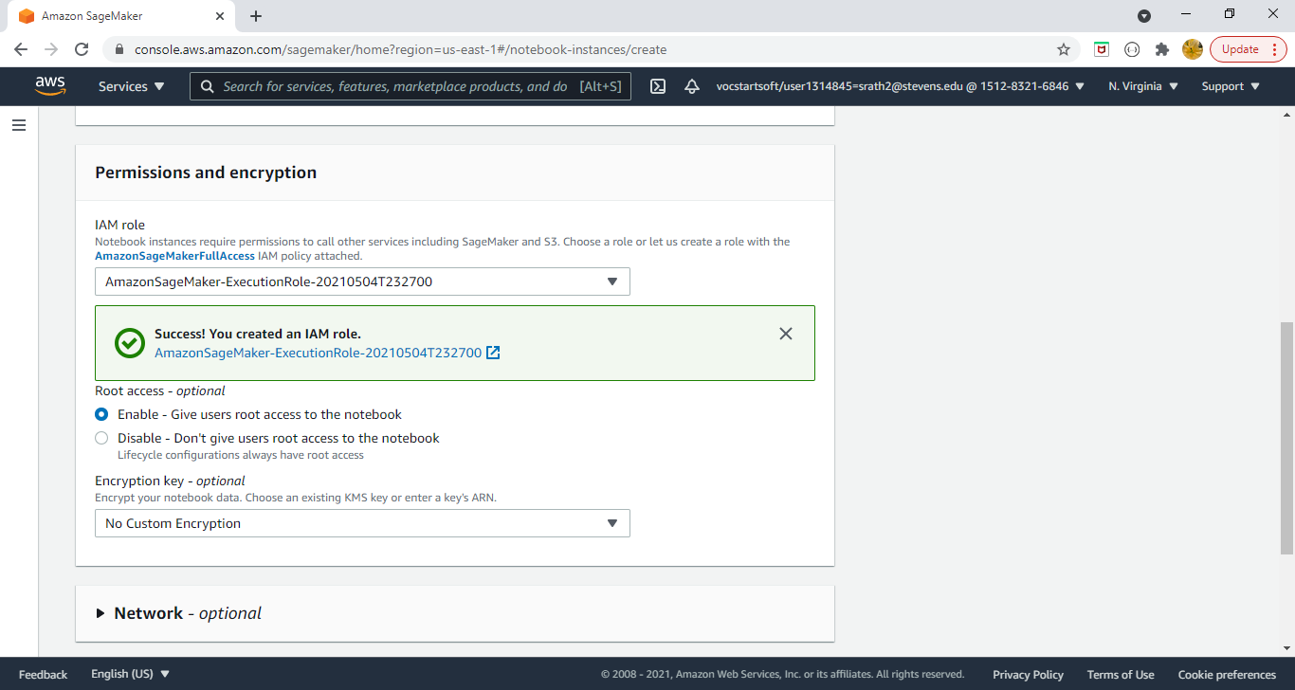

1. **After the successful creation of IAM role, notebook instance is created**

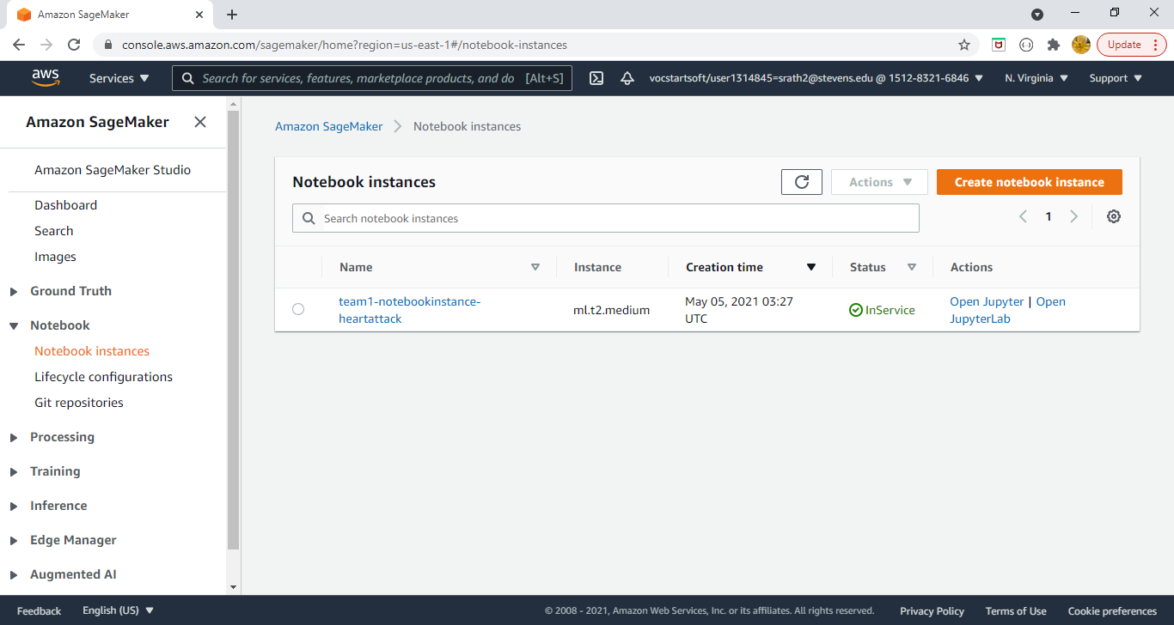

1. **After the successful creation of notebook instance, for deploying the models we will go to Jupyter notebook. We can use Jupyter notebook in our notebook instance to prepare and process data, write code to train models, deploy models to SageMaker hosting, and test or validate your models.**
2. **We have uploaded our Heart Prediction.ipynb file to the Jupyter instance which includes the programming part of our all the different classifiers which we have used in our project.**
3. **Once we have clicked on Heart Prediction.ipynb, it showed the programming part which we have implemented with different classifiers to predict the heart attack.**

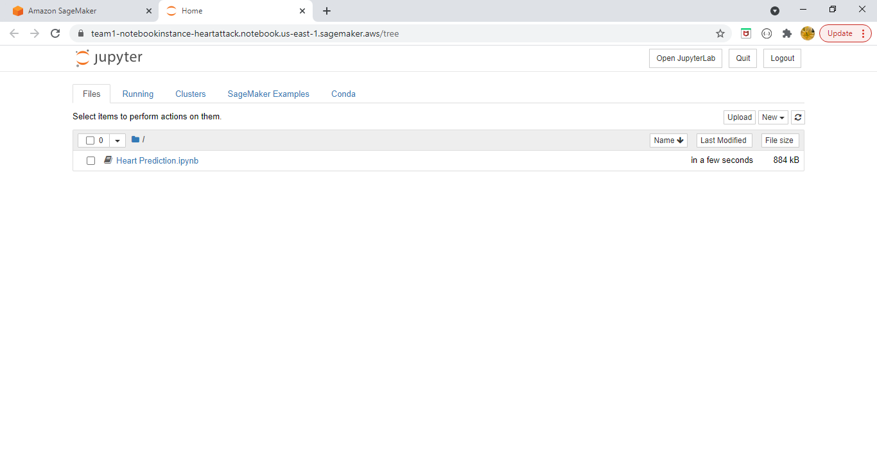

1. **We have imported all the required libraries which were required for the project.**

**For Linear algebra numpy is imported**

A **numpy array** is a grid of values, all of the same type, and is indexed by a tuple of nonnegative integers. The number of dimensions is the rank of the **array**; the shape of an **array** is a tuple of integers giving the size of the **array** along each dimension

For data processing pandas is imported

**pandas** is a fast, powerful, flexible and easy to use open source **data analysis** and manipulation tool, built on top of the Python programming language.

For building the model

**from** **sklearn.metrics** **import** accuracy\_score

Accuracy classification score.

In multilabel classification, this function computes subset accuracy: the set of labels predicted for a sample must exactly match the corresponding set of labels in y\_true.

**from** **sklearn.metrics** **import** confusion\_matrix

By definition a confusion matrix  is such that  is equal to the number of observations known to be in group  but predicted to be in group .

**from** **sklearn.preprocessing** **import** StandardScaler

Standardize features by removing the mean and scaling to unit variance

The standard score of a sample x is calculated as:

z = (x - u) / s

where u is the mean of the training samples or zero if with\_mean=False, and s is the standard deviation of the training samples or one if with\_std=False.

**from** **sklearn.linear\_model** **import** LogisticRegression

Logistic Regression (aka logit, MaxEnt) classifier.

In the multiclass case, the training algorithm uses the one-vs-rest (OvR) scheme if the ‘multi\_class’ option is set to ‘ovr’, and uses the cross-entropy loss if the ‘multi\_class’ option is set to ‘multinomial’. (Currently the ‘multinomial’ option is supported only by the ‘lbfgs’, ‘sag’, ‘saga’ and ‘newton-cg’ solvers.)

This class implements regularized logistic regression using the ‘liblinear’ library, ‘newton-cg’, ‘sag’, ‘saga’ and ‘lbfgs’ solvers. **Note that regularization is applied by default**. It can handle both dense and sparse input. Use C-ordered arrays or CSR matrices containing 64-bit floats for optimal performance; any other input format will be converted (and copied).

The ‘newton-cg’, ‘sag’, and ‘lbfgs’ solvers support only L2 regularization with primal formulation, or no regularization. The ‘liblinear’ solver supports both L1 and L2 regularization, with a dual formulation only for the L2 penalty. The Elastic-Net regularization is only supported by the ‘saga’ solver.

**from** **sklearn.neighbors** **import** KNeighborsClassifier

[**KNeighborsClassifier**](https://scikit-learn.org/stable/modules/generated/sklearn.neighbors.KNeighborsClassifier.html#sklearn.neighbors.KNeighborsClassifier) implements learning based on the k nearest neighbors of each query point, where k is an integer value specified by the user. **[RadiusNeighborsClassifier](https://scikit-learn.org/stable/modules/generated/sklearn.neighbors.RadiusNeighborsClassifier.html" \l "sklearn.neighbors.RadiusNeighborsClassifier" \o "sklearn.neighbors.RadiusNeighborsClassifier)** implements learning based on the number of neighbors within a fixed radius r of each training point, where r is a floating-point value specified by the user.

The k-neighbors classification in **[KNeighborsClassifier](https://scikit-learn.org/stable/modules/generated/sklearn.neighbors.KNeighborsClassifier.html" \l "sklearn.neighbors.KNeighborsClassifier" \o "sklearn.neighbors.KNeighborsClassifier)** is the most commonly used technique. The optimal choice of the value k is highly data-dependent: in general a larger k suppresses the effects of noise, but makes the classification boundaries less distinct.

In cases where the data is not uniformly sampled, radius-based neighbors classification in **[RadiusNeighborsClassifier](https://scikit-learn.org/stable/modules/generated/sklearn.neighbors.RadiusNeighborsClassifier.html" \l "sklearn.neighbors.RadiusNeighborsClassifier" \o "sklearn.neighbors.RadiusNeighborsClassifier)** can be a better choice. The user specifies a fixed radius r, such that points in sparser neighborhoods use fewer nearest neighbors for the classification. For high-dimensional parameter spaces, this method becomes less effective due to the so-called “curse of dimensionality”.

The basic nearest neighbors classification uses uniform weights: that is, the value assigned to a query point is computed from a simple majority vote of the nearest neighbors. Under some circumstances, it is better to weight the neighbors such that nearer neighbors contribute more to the fit. This can be accomplished through the weights keyword. The default value, weights = 'uniform', assigns uniform weights to each neighbor. weights = 'distance' assigns weights proportional to the inverse of the distance from the query point. Alternatively, a user-defined function of the distance can be supplied to compute the weights.

**from** **sklearn.naive\_bayes** **import** GaussianNB

[**GaussianNB**](https://scikit-learn.org/stable/modules/generated/sklearn.naive_bayes.GaussianNB.html#sklearn.naive_bayes.GaussianNB) implements the Gaussian Naive Bayes algorithm for classification. The likelihood of the features is assumed to be Gaussian:

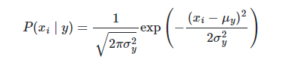

P(xi∣y)=12πσy2exp⁡(−(xi−μy)22σy2)

The parameters σy and μy are estimated using maximum likelihood.

**from** **sklearn.neural\_network** **import** MLPClassifier

This model optimizes the log-loss function using LBFGS or stochastic gradient descent.

**from** **sklearn.svm** **import** SVC

C-Support Vector Classification.

The implementation is based on libsvm. The fit time scales at least quadratically with the number of samples and may be impractical beyond tens of thousands of samples. For large datasets consider using **[LinearSVC](https://scikit-learn.org/stable/modules/generated/sklearn.svm.LinearSVC.html" \l "sklearn.svm.LinearSVC" \o "sklearn.svm.LinearSVC)** or **[SGDClassifier](https://scikit-learn.org/stable/modules/generated/sklearn.linear_model.SGDClassifier.html" \l "sklearn.linear_model.SGDClassifier" \o "sklearn.linear_model.SGDClassifier)** instead, possibly after a **[Nystroem](https://scikit-learn.org/stable/modules/generated/sklearn.kernel_approximation.Nystroem.html" \l "sklearn.kernel_approximation.Nystroem" \o "sklearn.kernel_approximation.Nystroem)** transformer.

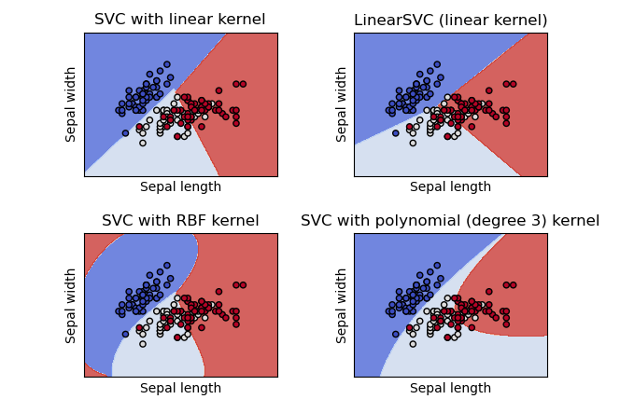

**from** **sklearn.tree** **import** DecisionTreeClassifier

**Decision Trees (DTs)** are a non-parametric supervised learning method used for [classification](https://scikit-learn.org/stable/modules/tree.html#tree-classification) and [regression](https://scikit-learn.org/stable/modules/tree.html#tree-regression). The goal is to create a model that predicts the value of a target variable by learning simple decision rules inferred from the data features. A tree can be seen as a piecewise constant approximation.

For instance, in the example below, decision trees learn from data to approximate a sine curve with a set of if-then-else decision rules. The deeper the tree, the more complex the decision rules and the fitter the model.

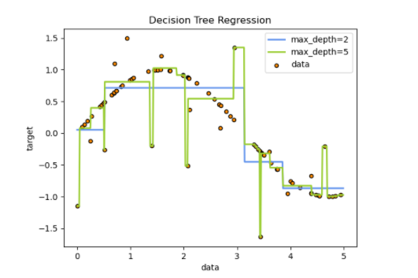

**from** **sklearn.ensemble** **import** RandomForestClassifier

A random forest classifier.

A random forest is a meta estimator that fits a number of decision tree classifiers on various sub-samples of the dataset and uses averaging to improve the predictive accuracy and control over-fitting. The sub-sample size is controlled with the max\_samples parameter if bootstrap=True (default), otherwise the whole dataset is used to build each tree.

**from** **sklearn.ensemble** **import** GradientBoostingClassifier

Gradient Boosting for classification.

GB builds an additive model in a forward stage-wise fashion; it allows for the optimization of arbitrary differentiable loss functions. In each stage n\_classes\_ regression trees are fit on the negative gradient of the binomial or multinomial deviance loss function. Binary classification is a special case where only a single regression tree is induced.

[Gradient Tree Boosting](https://en.wikipedia.org/wiki/Gradient_boosting) or Gradient Boosted Decision Trees (GBDT) is a generalization of boosting to arbitrary differentiable loss functions. GBDT is an accurate and effective off-the-shelf procedure that can be used for both regression and classification problems in a variety of areas including Web search ranking and ecology.

**from** **sklearn.ensemble** **import** AdaBoostClassifier

An AdaBoost classifier is a meta-estimator that begins by fitting a classifier on the original dataset and then fits additional copies of the classifier on the same dataset but where the weights of incorrectly classified instances are adjusted such that subsequent classifiers focus more on difficult cases.

The core principle of AdaBoost is to fit a sequence of weak learners (i.e., models that are only slightly better than random guessing, such as small decision trees) on repeatedly modified versions of the data. The predictions from all of them are then combined through a weighted majority vote (or sum) to produce the final prediction

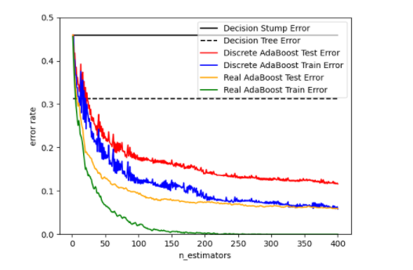

**import** **xgboost** **as** **xgb**

**XGBoost** is an algorithm that has recently been dominating applied machine learning and Kaggle competitions for structured or tabular data. **XGBoost** is an implementation of gradient boosted decision trees designed for speed and performance.

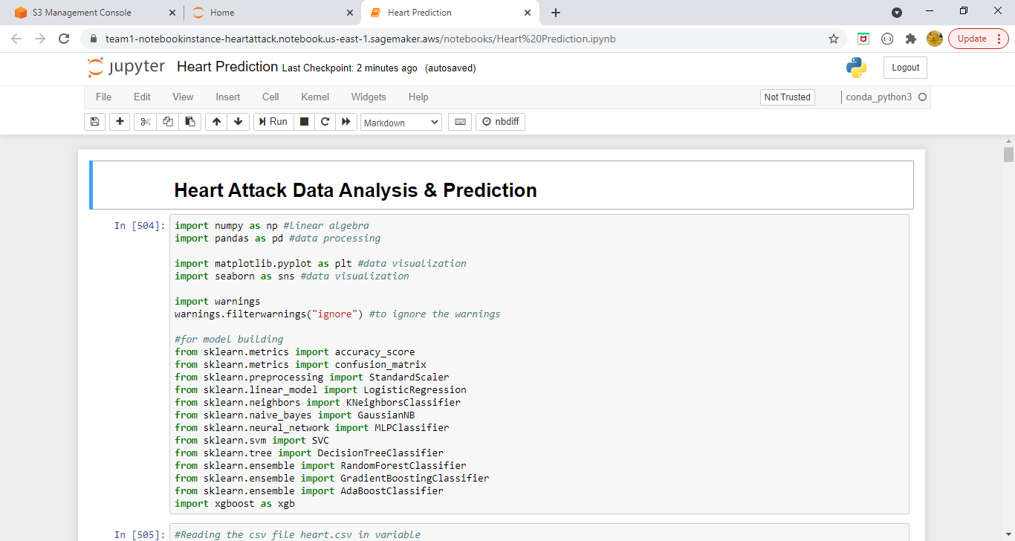

1. **We have specified the S3 bucket name which we have created to store the dataset , to read from it.**
2. **After reading the data from the S3 bucket we are looking at the first five rows and last five rows.**

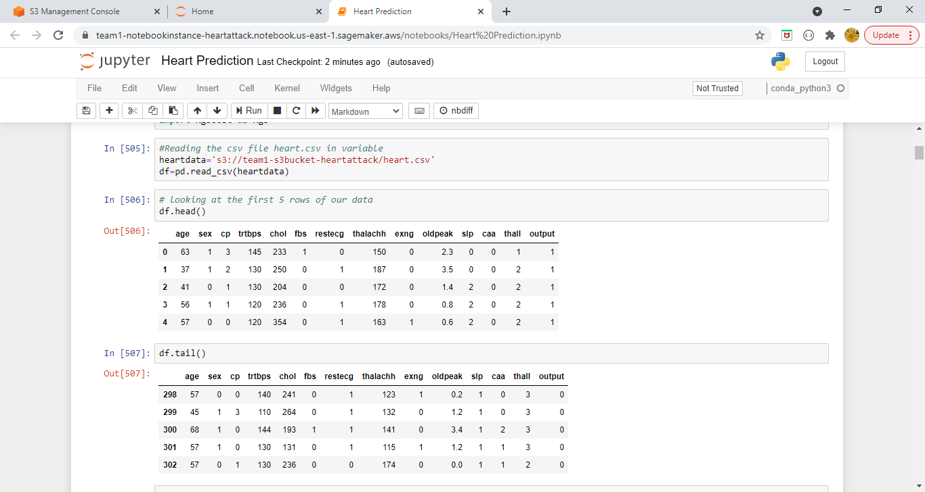

1. **Then we are checking the number of rows in our dataset and the number of columns.**
2. **We are also checking with the help of pandas library the datatype and non-null column for all the fields.**

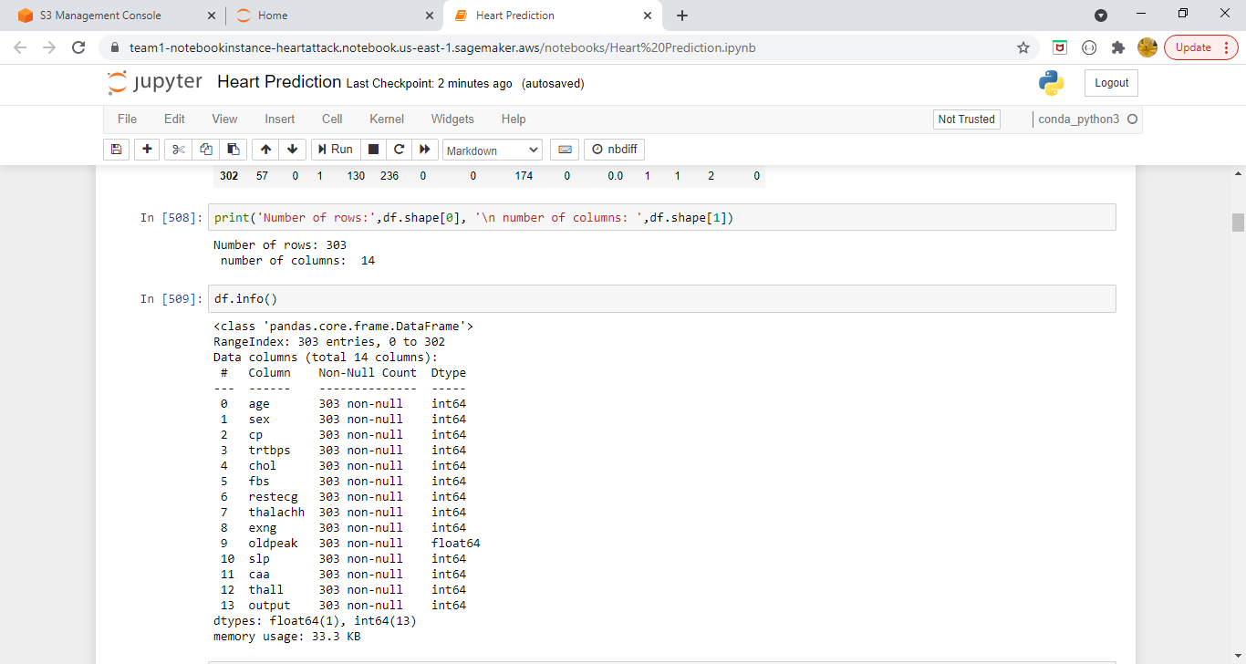

1. **Checking the columns if there are any fields which are null.**

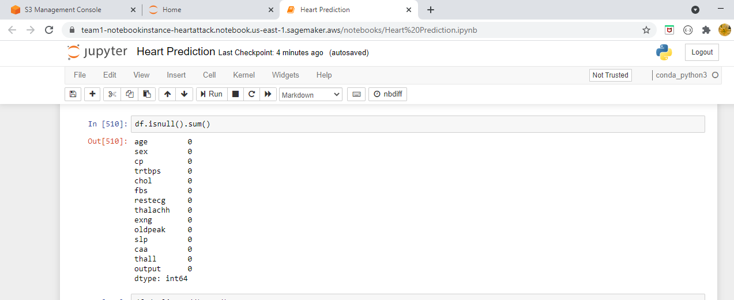

1. **Checking the data for duplicate values, if there are any then removing it from the dataset.**

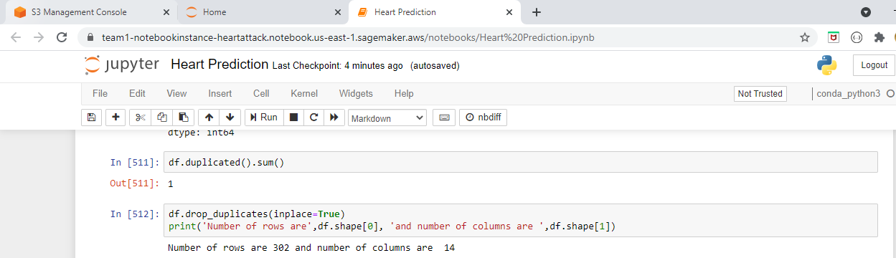

1. **We are calculating the total count, mean, standard deviation, minimum, and maximum for all the columns.**

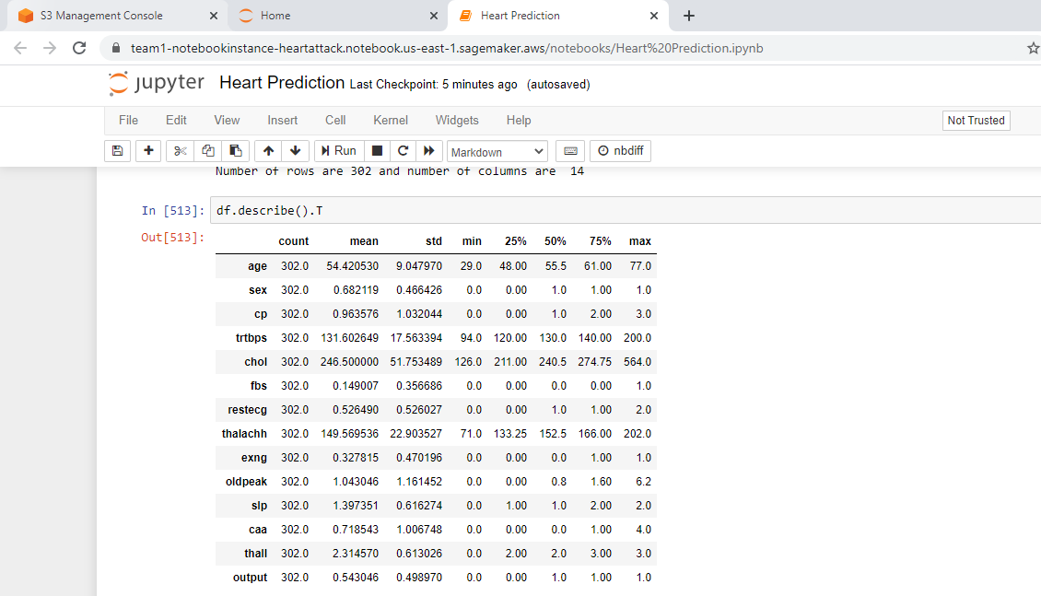

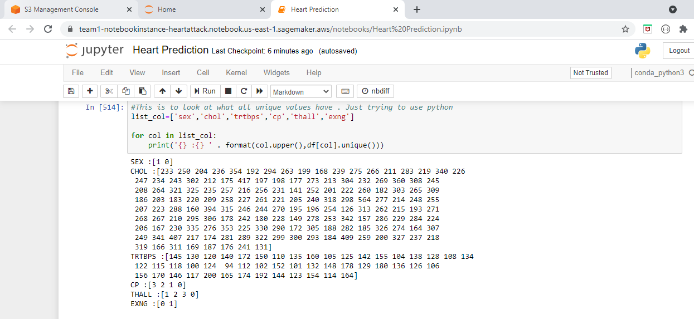

1. **Plotting the graph for the sex field which will the show the ratio of male and female.**

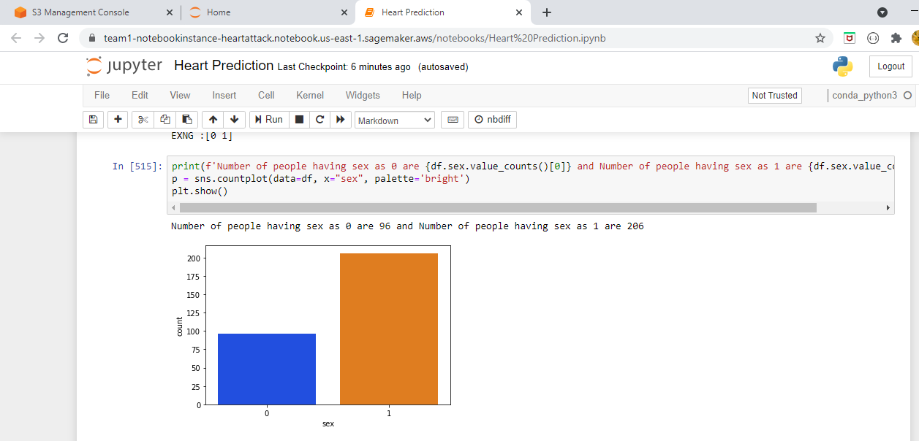

1. **Plotting the graph for chest pain which shows the number of individuals are having the chest pain according to the severity level.**

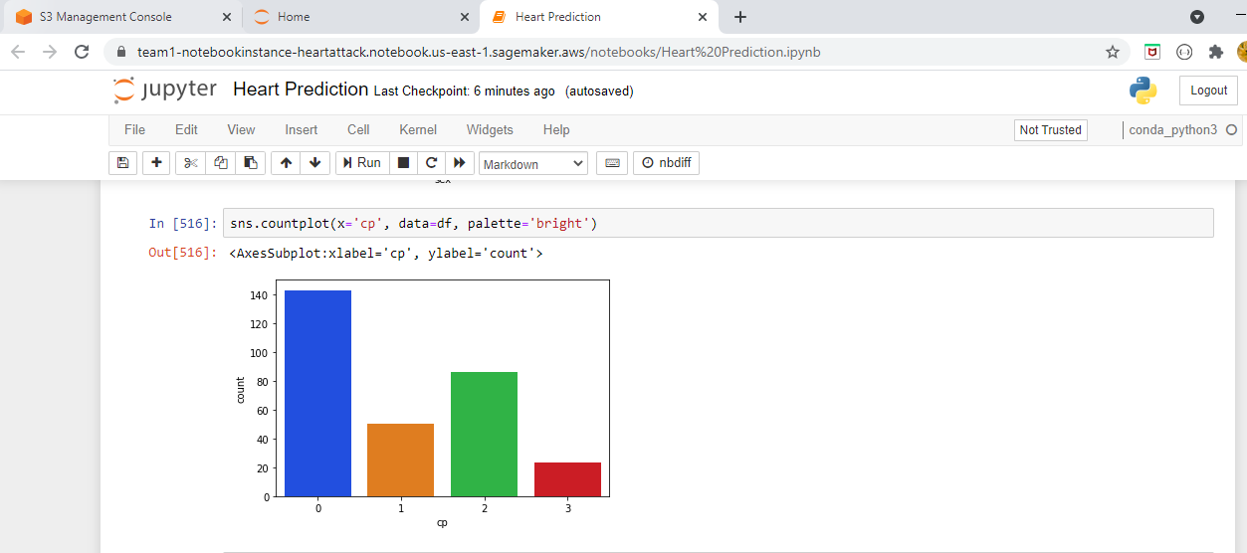

1. **Plotting the graph for the fasting blood sugar which shows how many individuals have the sugar level greater than 120.**

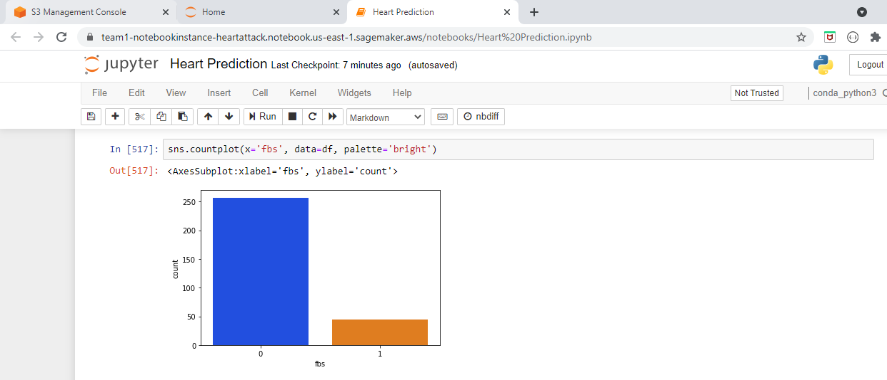

1. **Plotting the graph for the maximum heart rate achieved field which will show how many individuals have achieved the maximum heart rate.**

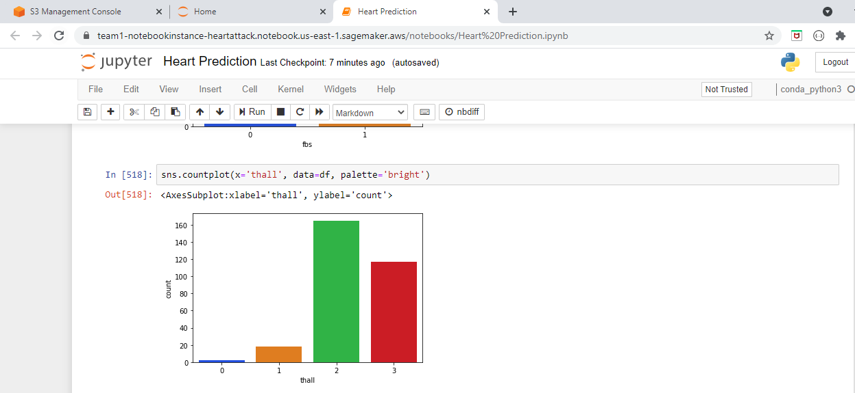

1. **Plotting the graph for the resting electrocardiographic results.**

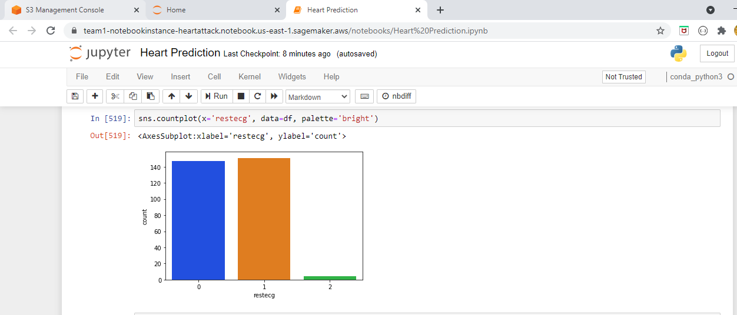

1. **Plotting the pair plots which will help in visualizing the data more clearly.**

**Pair Plots** are a really simple (one-line-of-code simple!) way to visualize relationships between each variable. It produces a matrix of relationships between each variable in your data for an instant examination of our data. It can also be a great jumping off point for determining types of regression analysis to use

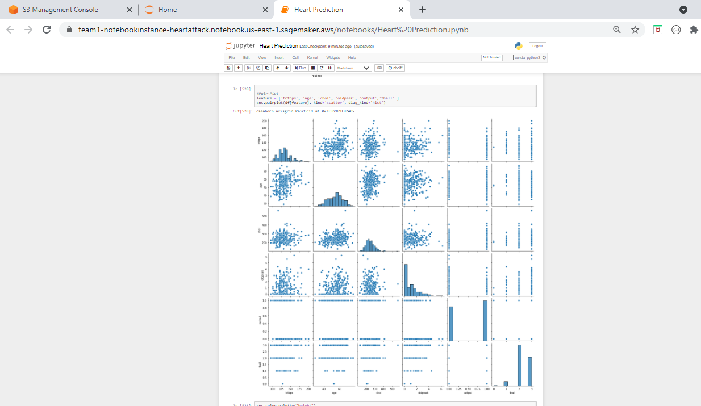

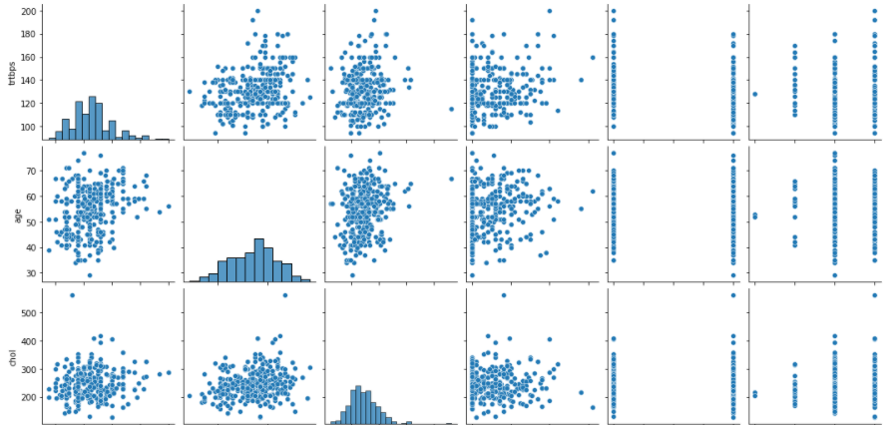

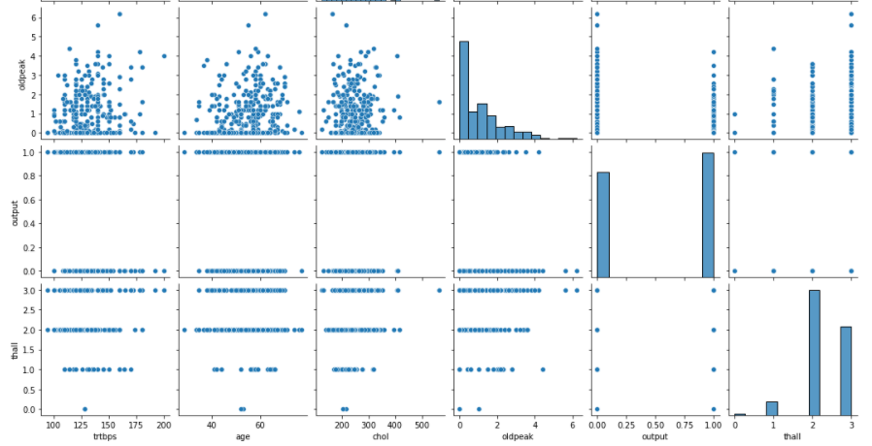

1. **Checking the outliers for resting blood pressure using distplot.**

Seaborn distplot lets you show a histogram with a line on it. This can be shown in all kinds of variations. We use seaborn in combination with matplotlib, the Python plotting module.

A distplot plots a univariate distribution of observations. The distplot() function combines the matplotlib hist function with the seaborn kdeplot() and rugplot() functions.

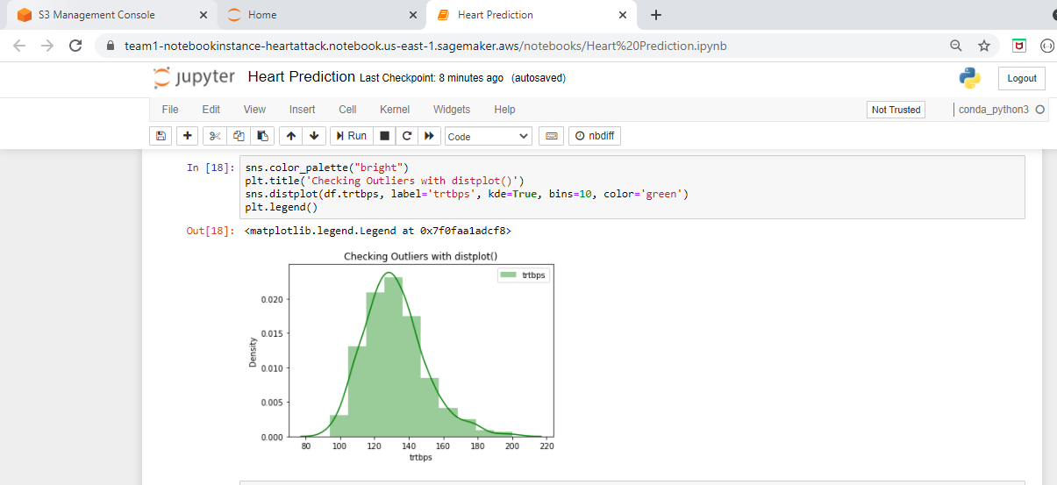

1. **Checking the outliers for cholestrol using distplot.**

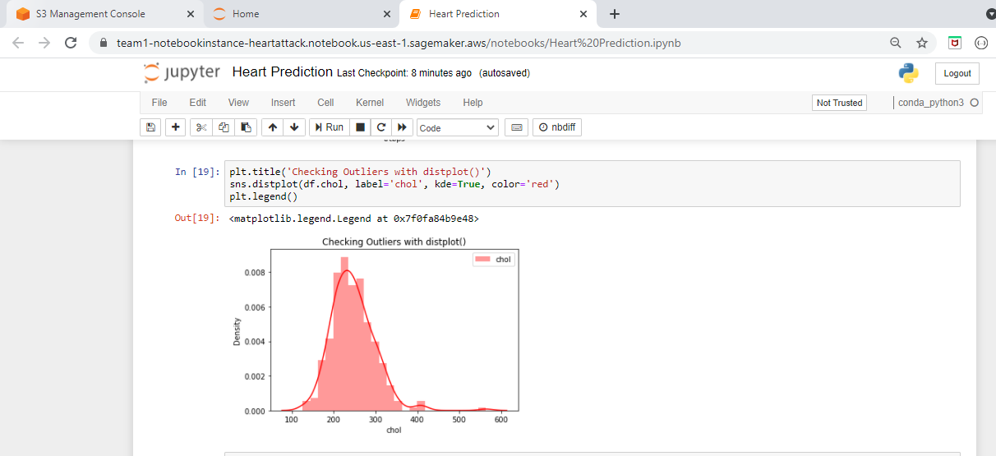

1. **Checking the outliers for maximum heart rate using distplot.**

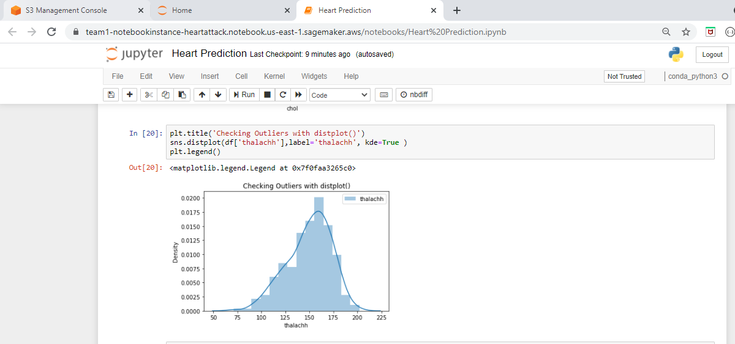

1. **Plotting the density plot for all the columns, cholesterol, heart rate, fasting blood sugar, age, sex etc.**

A Density Plot visualises the distribution of data over a continuous interval or time period. This chart is a variation of a [Histogram](http://datavizcatalogue.com/methods/histogram.html) that uses [kernel smoothing](https://en.wikipedia.org/wiki/Kernel_smoother) to plot values, allowing for smoother distributions by smoothing out the noise. The peaks of a Density Plot help display where values are concentrated over the interval.

An advantage Density Plots have over Histograms is that they're better at determining the [distribution shape](https://en.wikipedia.org/wiki/Shape_of_the_distribution) because they're not affected by the number of bins used (each bar used in a typical histogram). A Histogram comprising of only 4 bins wouldn't produce a distinguishable enough shape of distribution as a 20-bin Histogram would. However, with Density Plots, this isn't an issue.

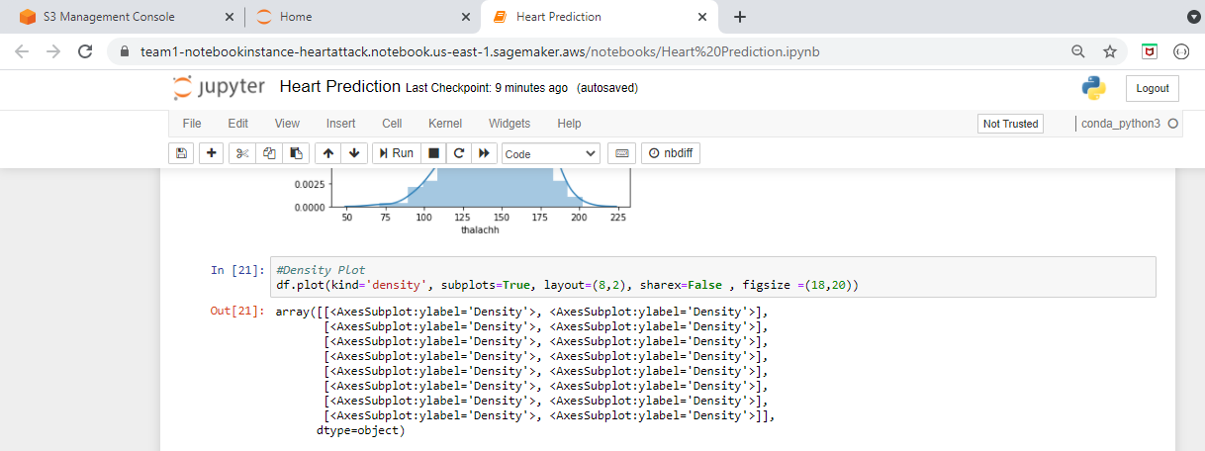

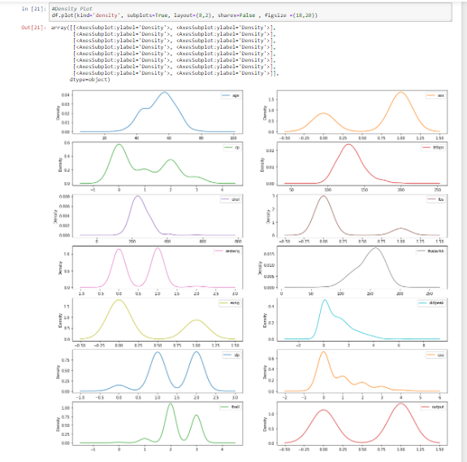

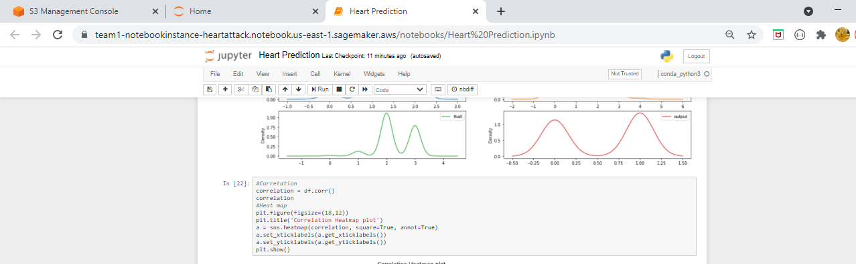

1. **Plotting the correlation heat map plot for all the columns, cholesterol, heart rate, fasting blood sugar, age, sex etc.**

A heatmap (aka heat map) depicts values for a main variable of interest across two axis variables as a grid of colored squares. The axis variables are divided into ranges like a [bar chart](https://chartio.com/learn/charts/bar-chart-complete-guide/) or [histogram](https://chartio.com/learn/charts/histogram-complete-guide/), and each cell’s color indicates the value of the main variable in the corresponding cell range.

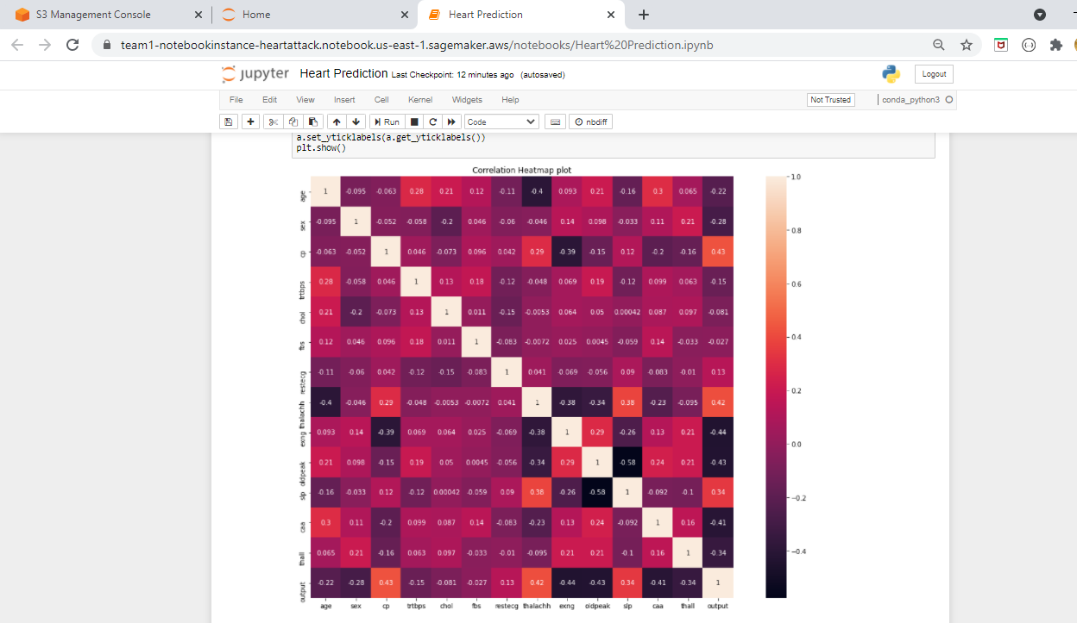

1. **Now we have scaled the data so that all the values will fall within the same range which will help in analyzing the data easily and in calculating the efficiency.**

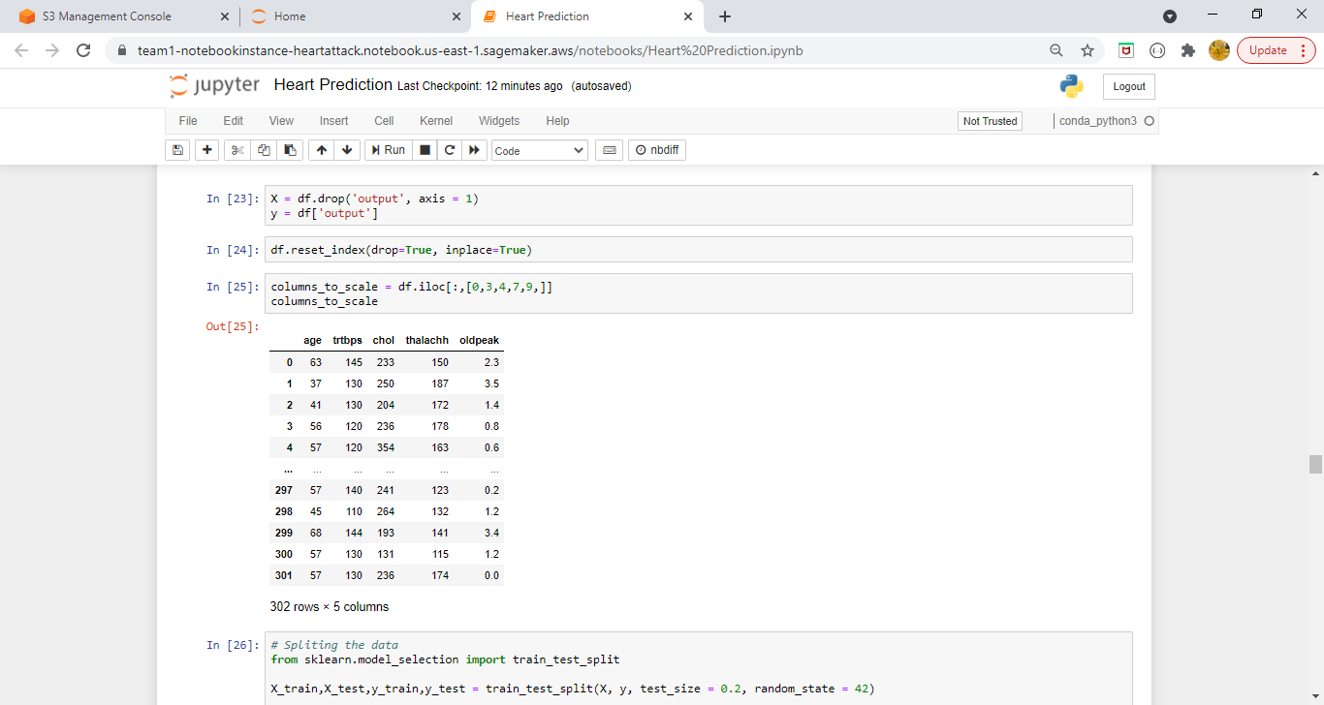

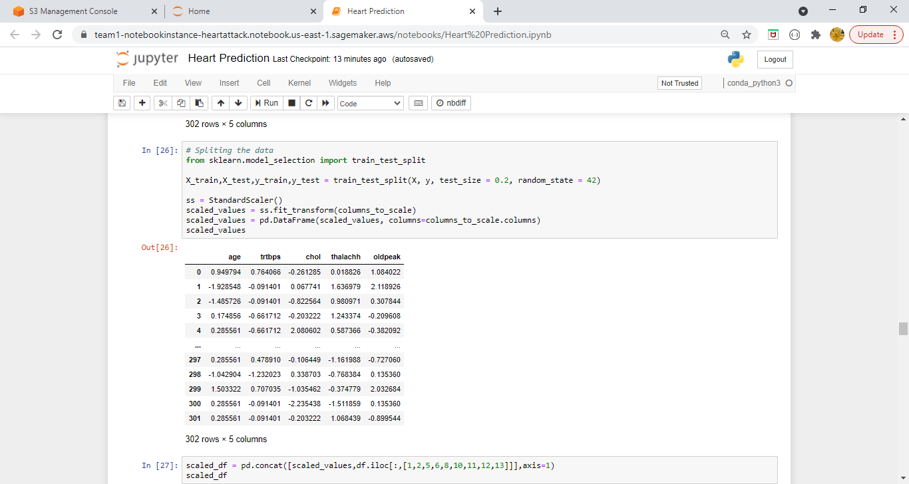

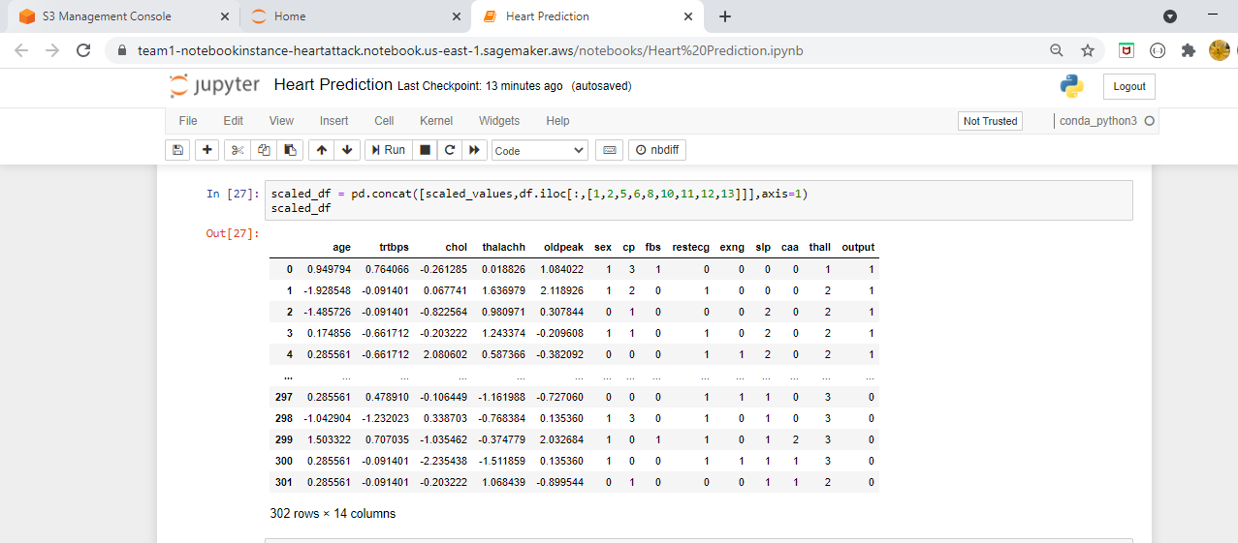

1. **Plotting the confusion matrix for all the 10 classifiers.**

A **confusion matrix** is a table that is often used to describe the performance of a classification model (or "classifier") on a set of test data for which the true values are known.

An example of confusion matrix for a binary classifier

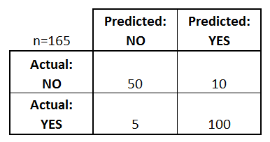

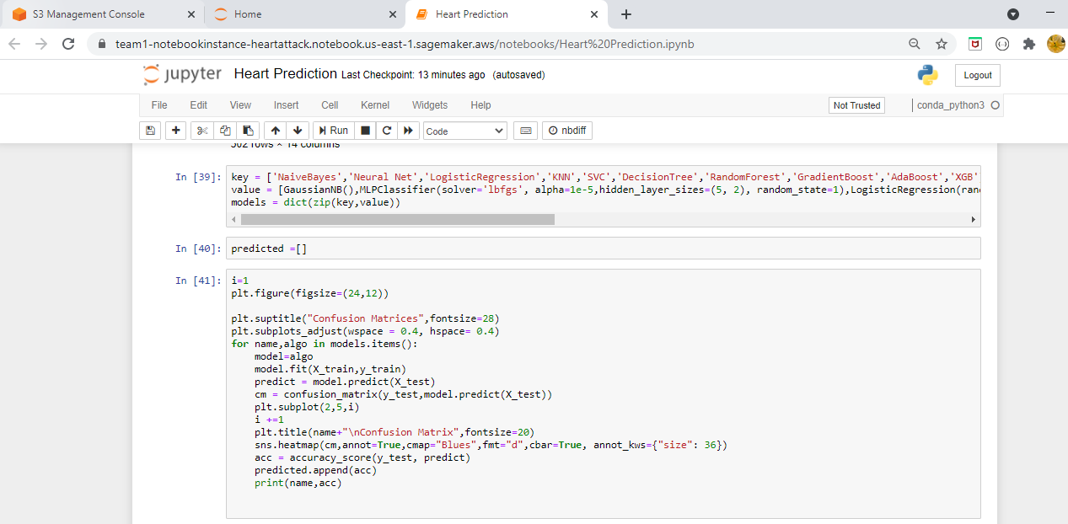

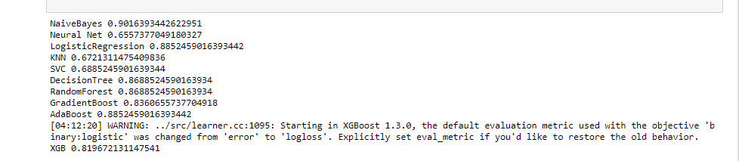

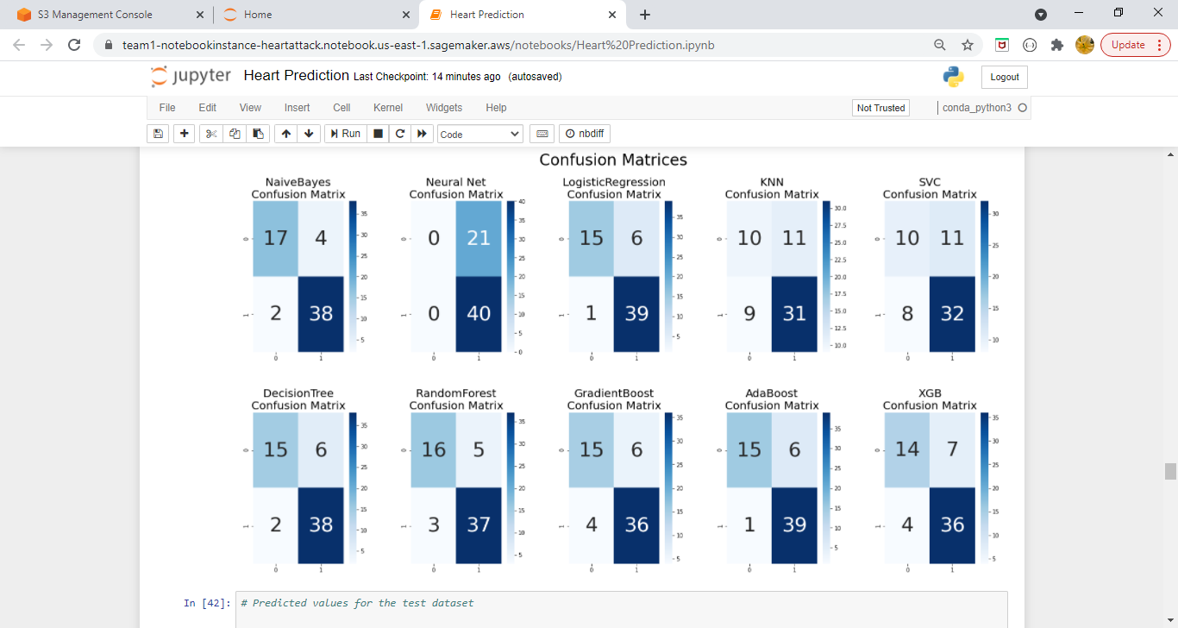

1. **Plotting the bar plot for all the 10 classifiers which will show us the efficiency and out of all the models we can see Naïve Bayes is the efficient one with efficiency more than 85 percentage.**

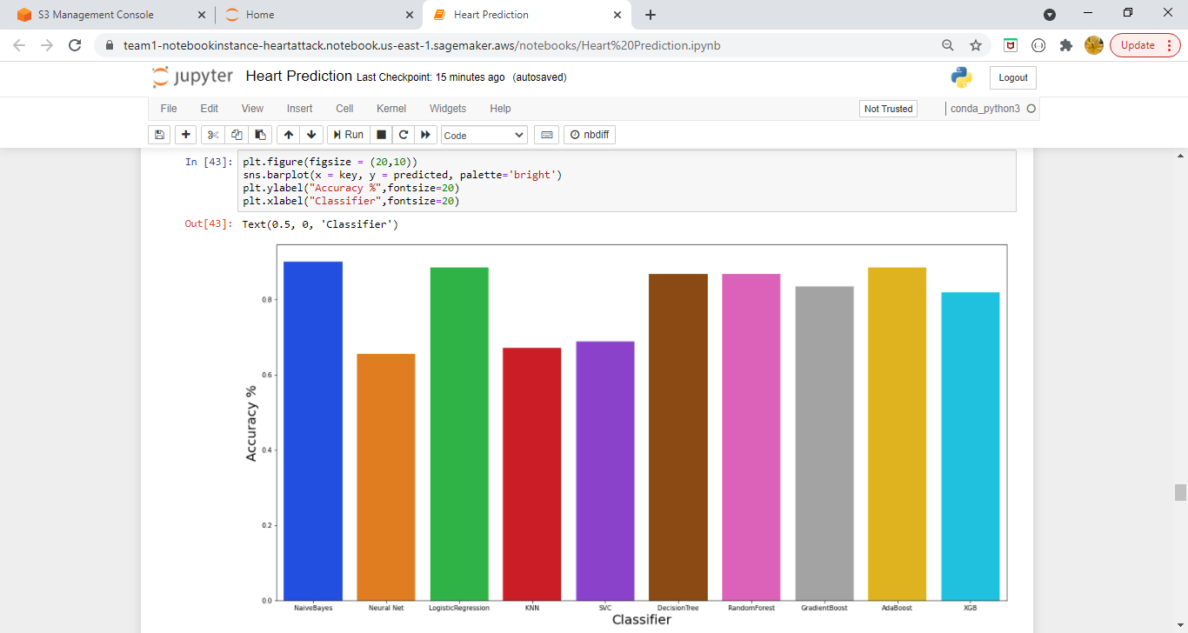

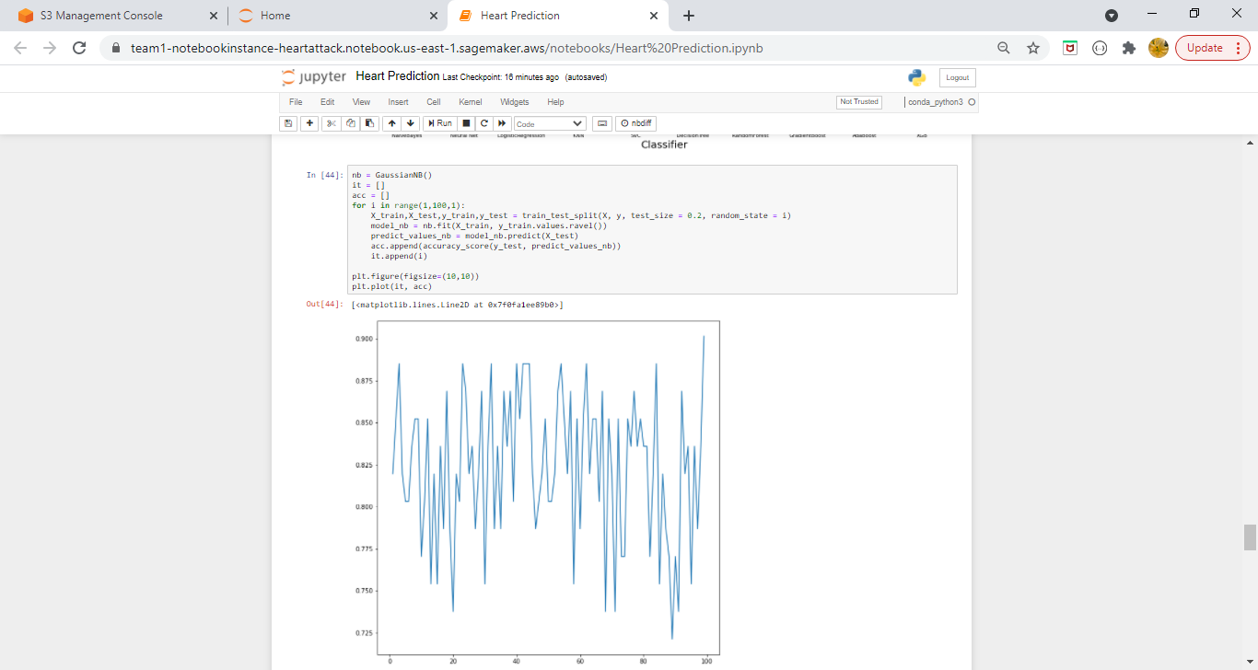

1. **Once we have found our efficient model which is Naïve Bayes, we are exporting it to the S3 bucket.**

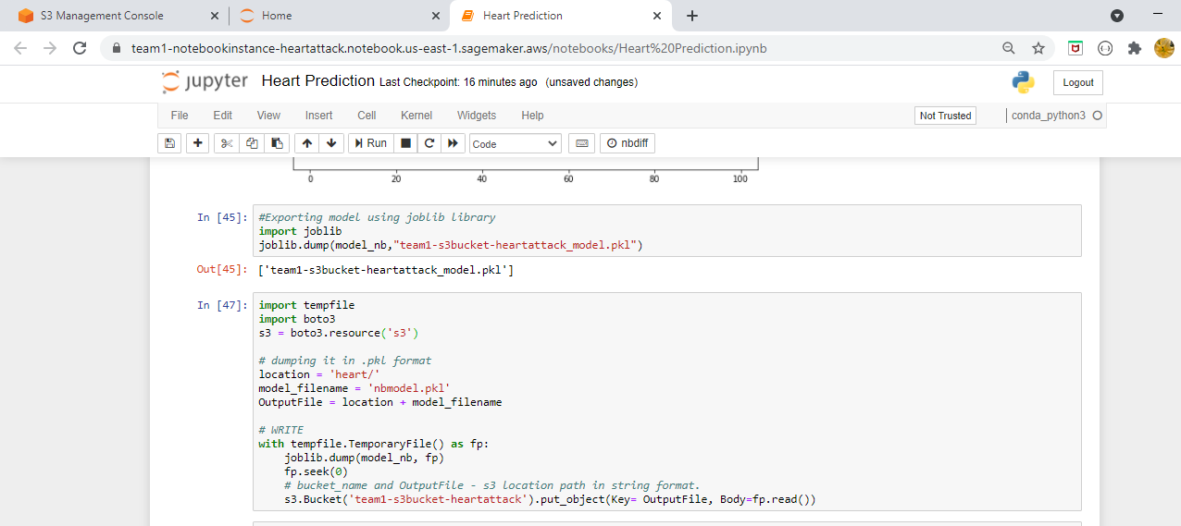

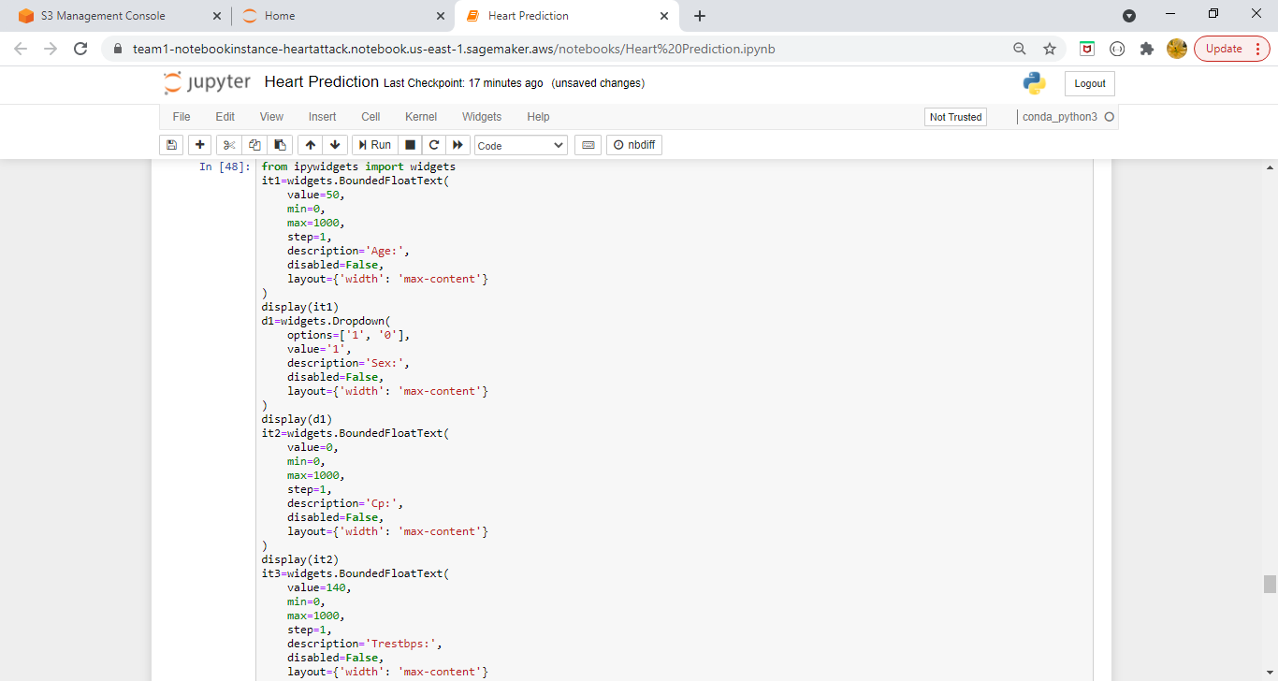

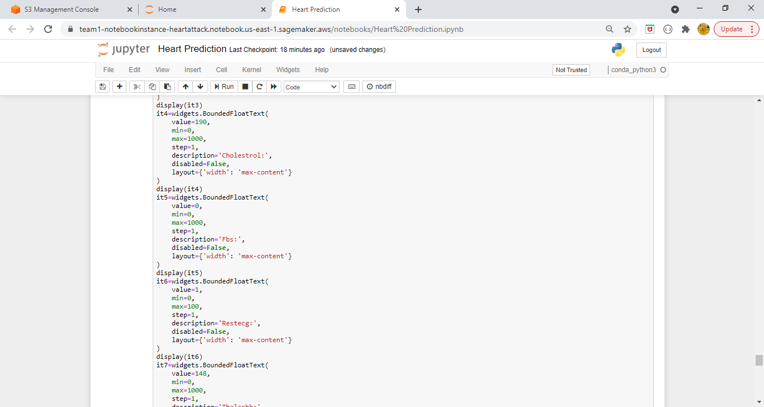

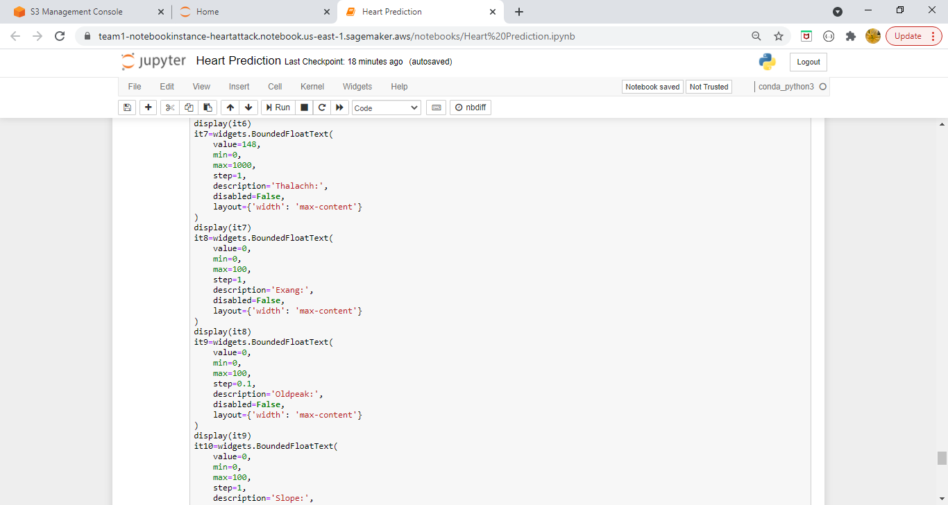

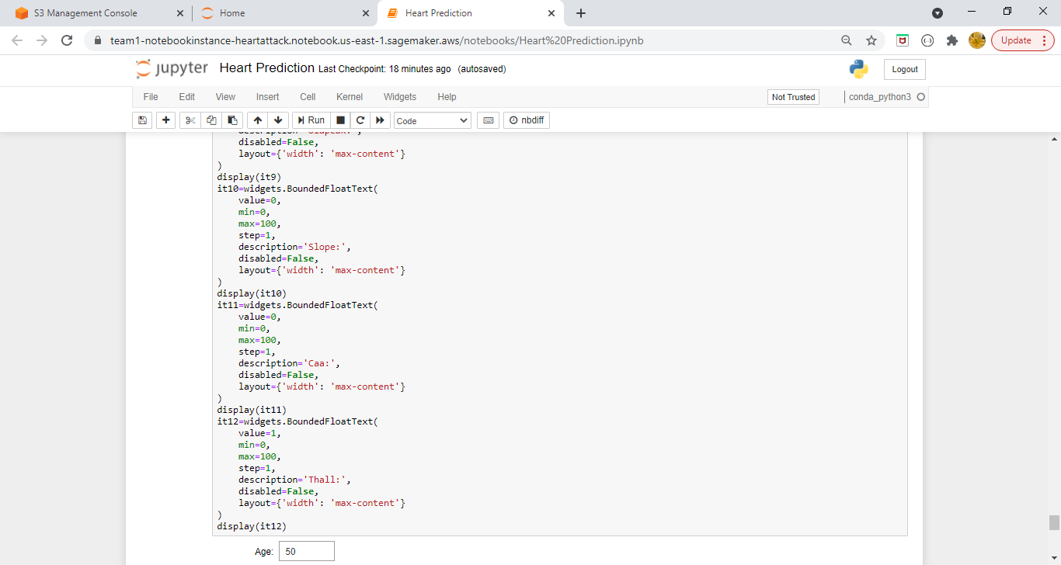

1. **Also provided the interface to enter values for an individual and on basis of the data, it will predict whether the individual is at risk of heart attack or not.**

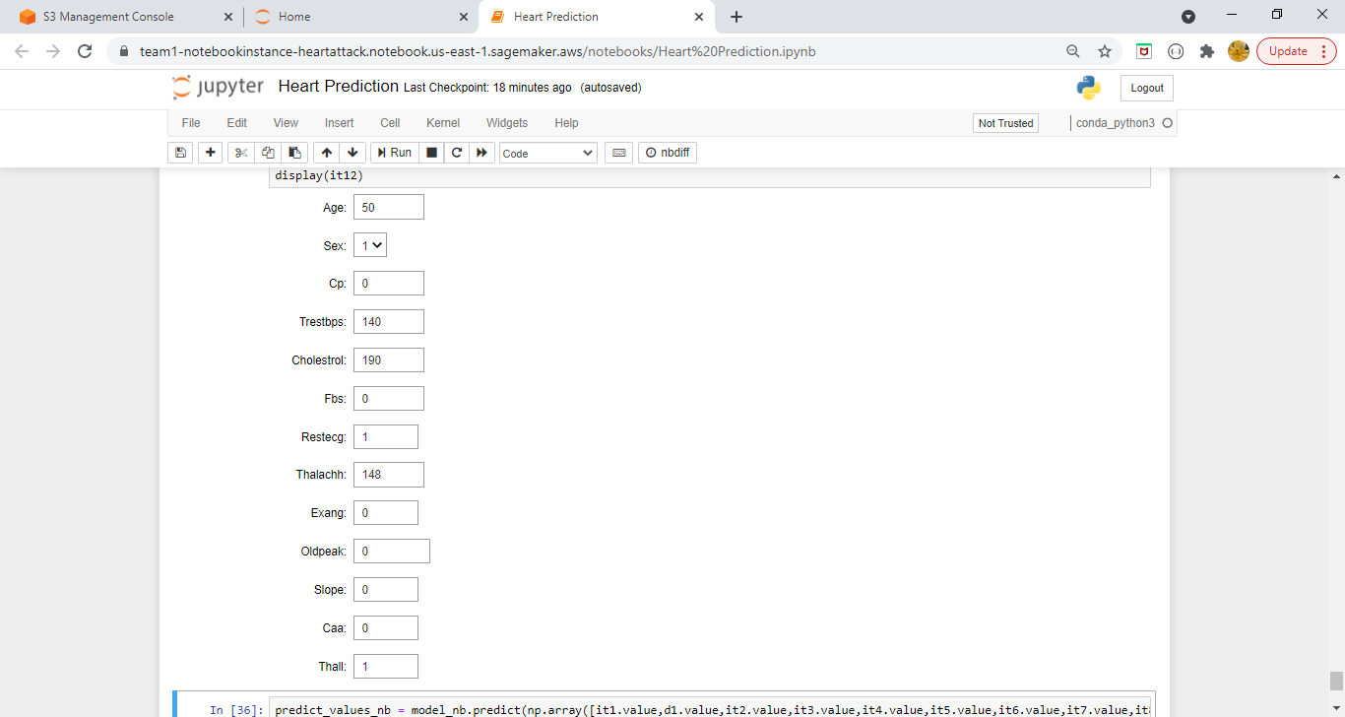

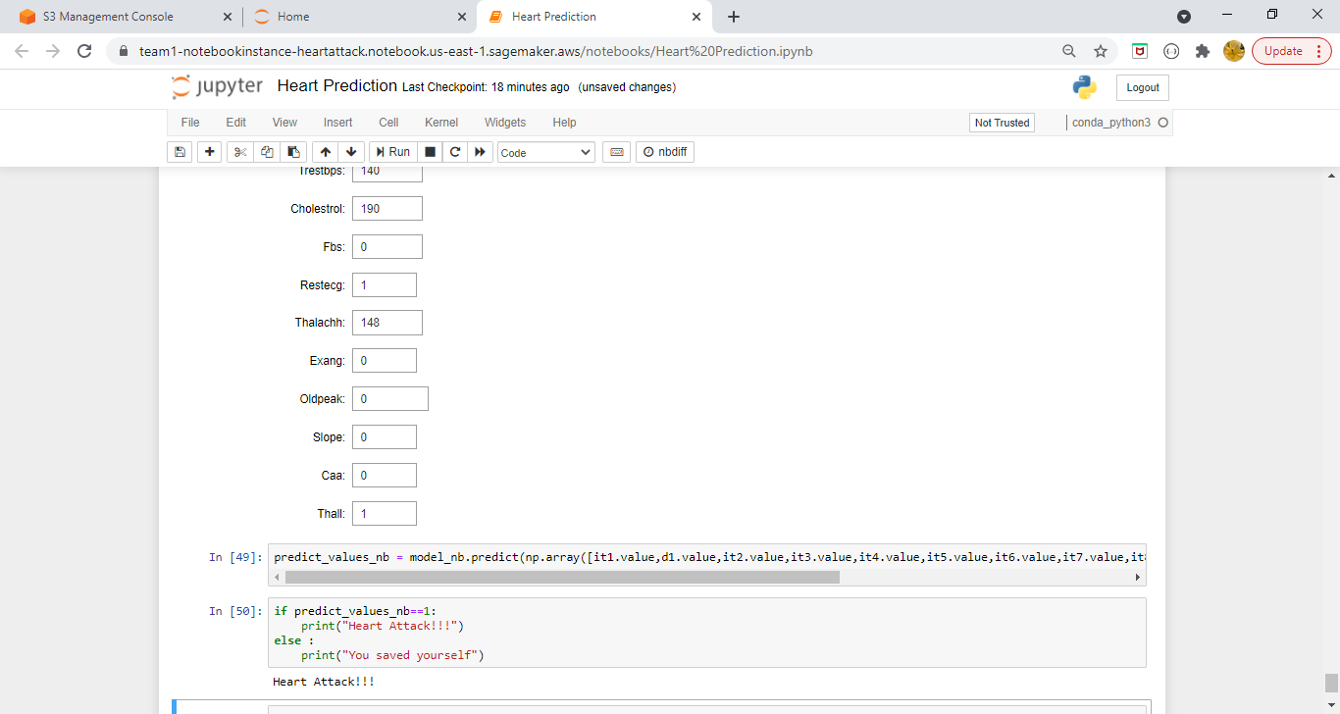

1. **Naïve Bayes Model is exported to S3 bucket under folder heart which we have defined in Heart Prediction.ipynb file.**

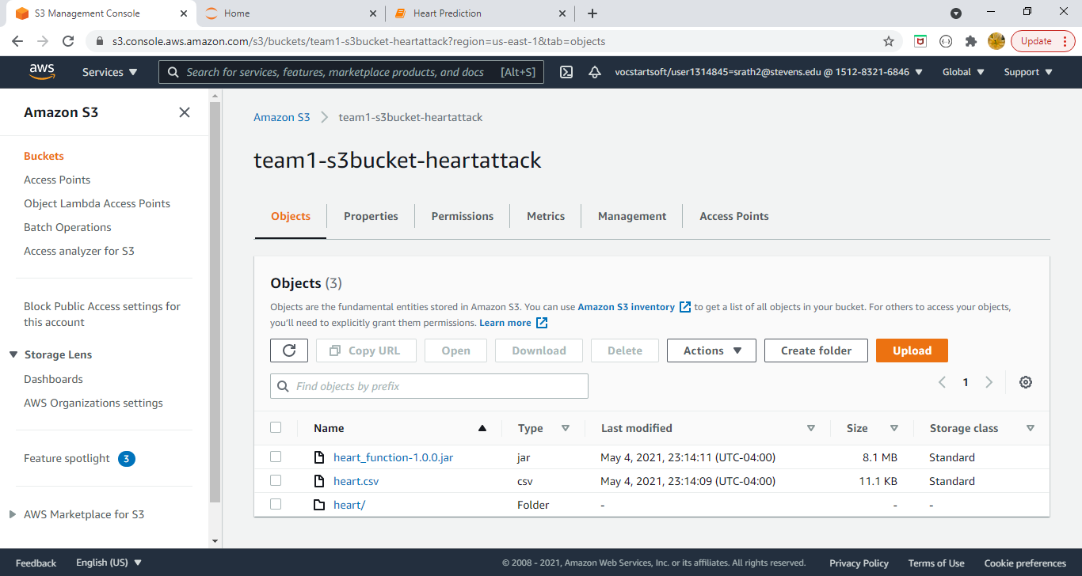

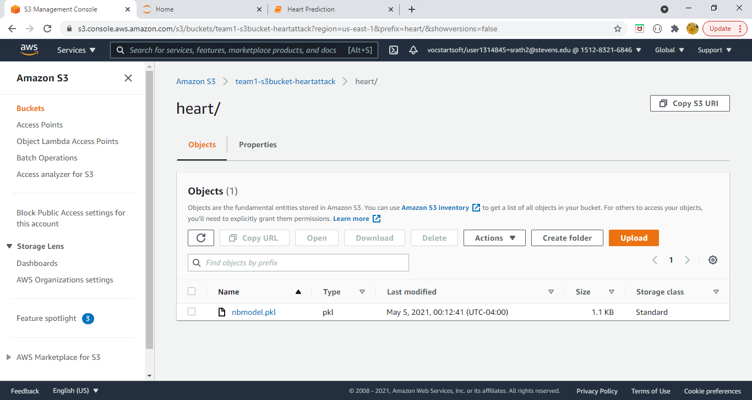

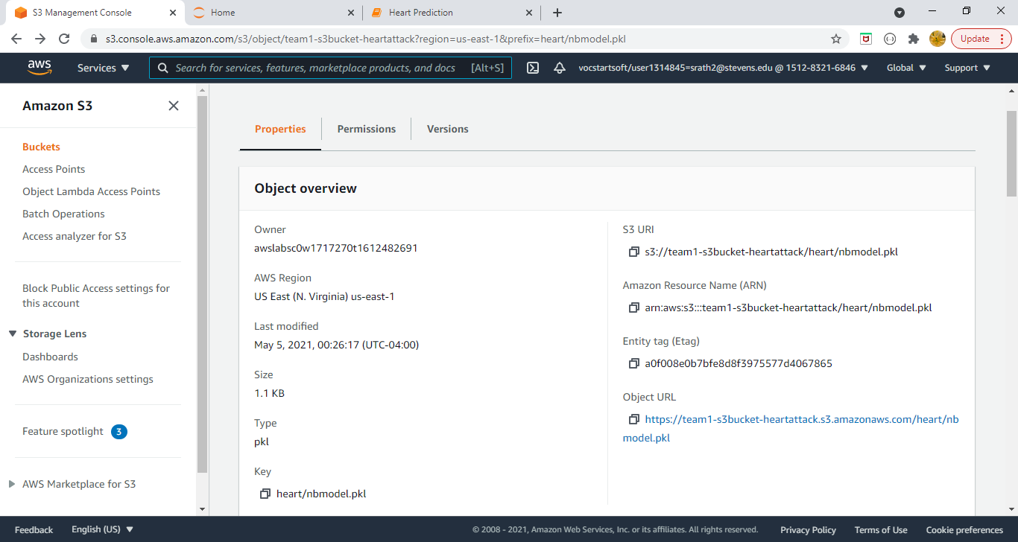

1. **Lambda function is created to trigger the end point URL so that if user submits his/her data via endpoint url then user will get the result whether he is at risk or heart attack or not.**

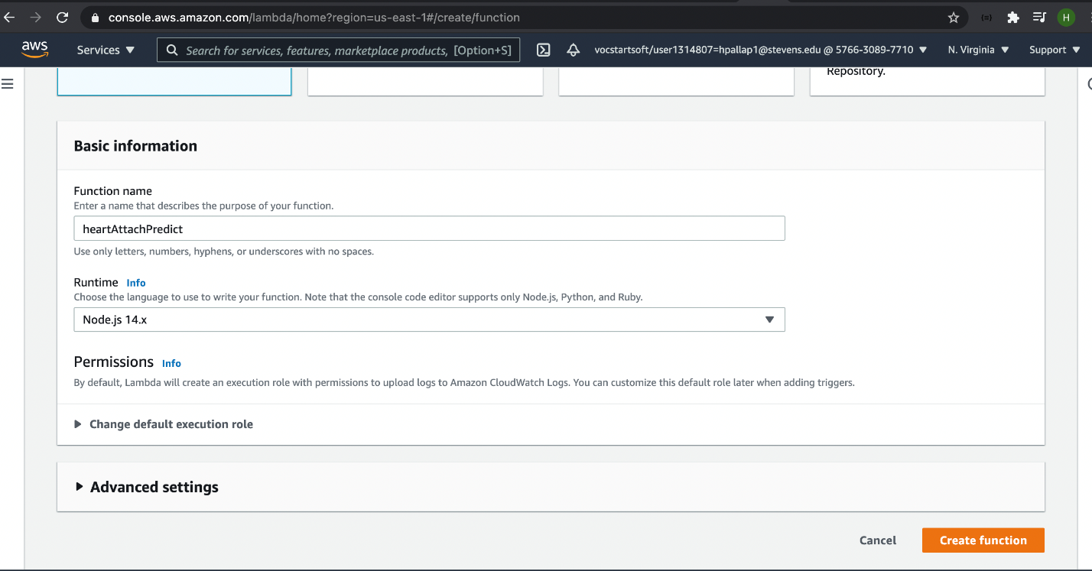

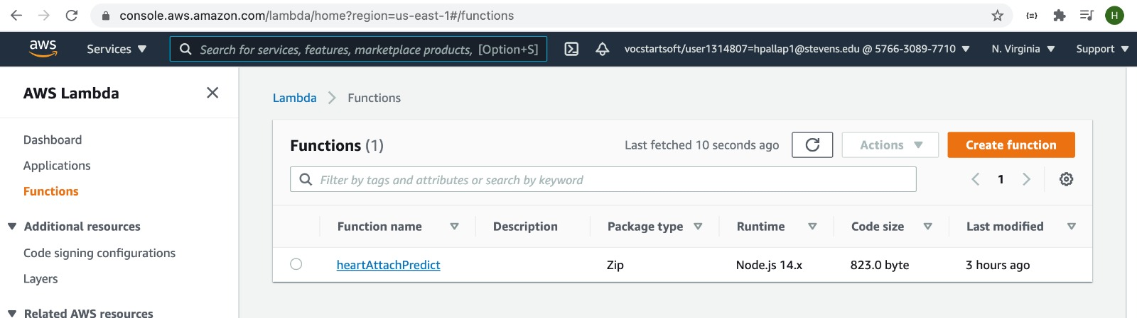

1. **Rest API trigger is added to invoke the lambda function whenever user hits the endpoint url.**

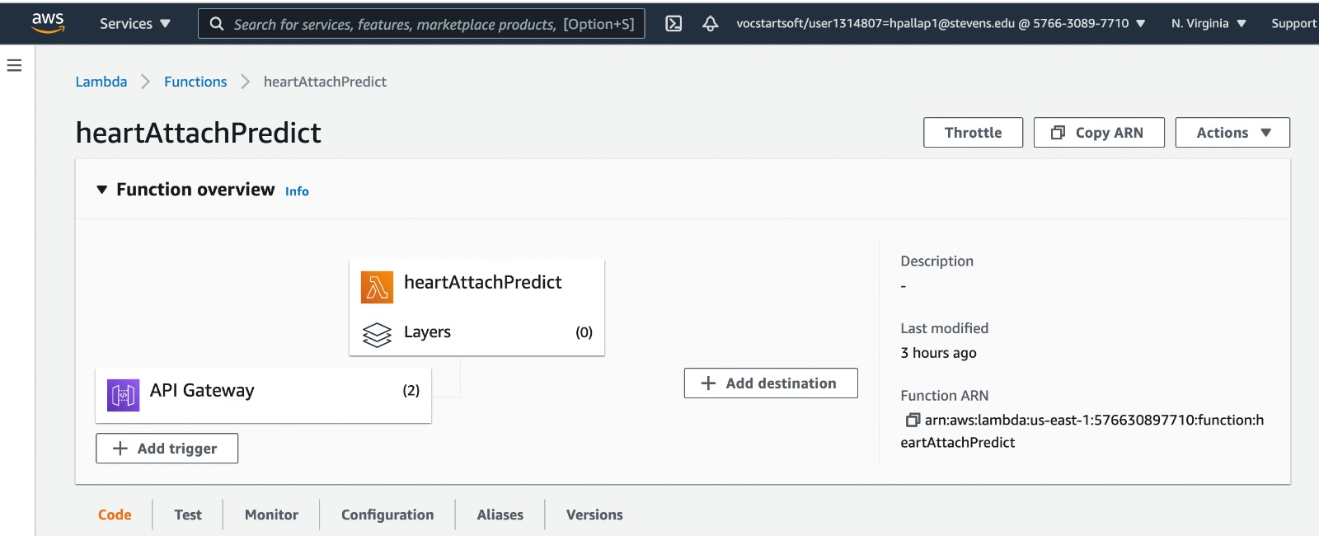

1. **Edited the code source part to predict the heart attack by using the model weight values which is calculated in notebook instance while training the model.**

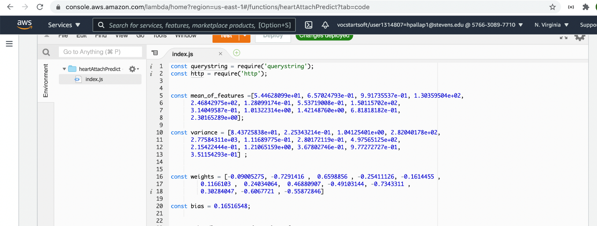

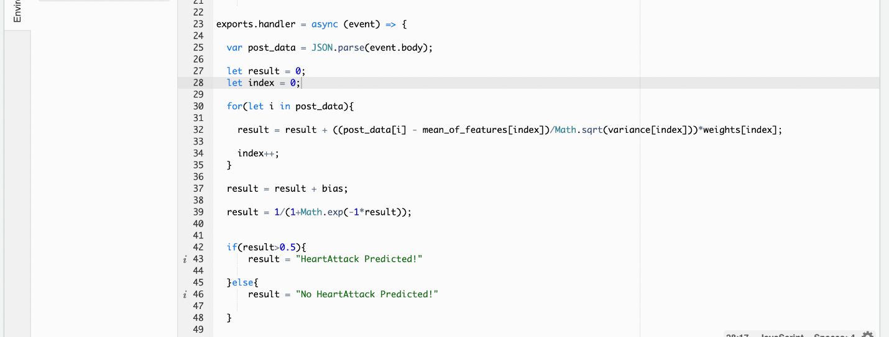

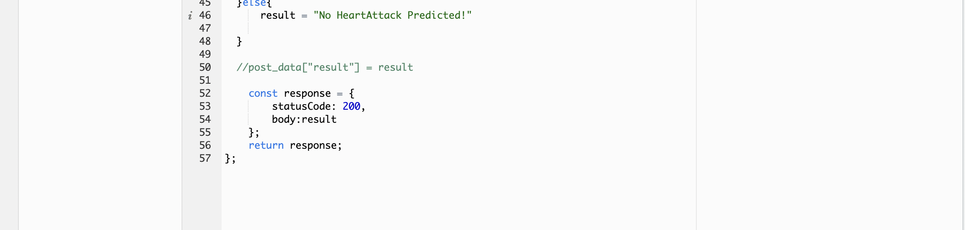

1. **Endpoint URL to invoke the lambda function.**

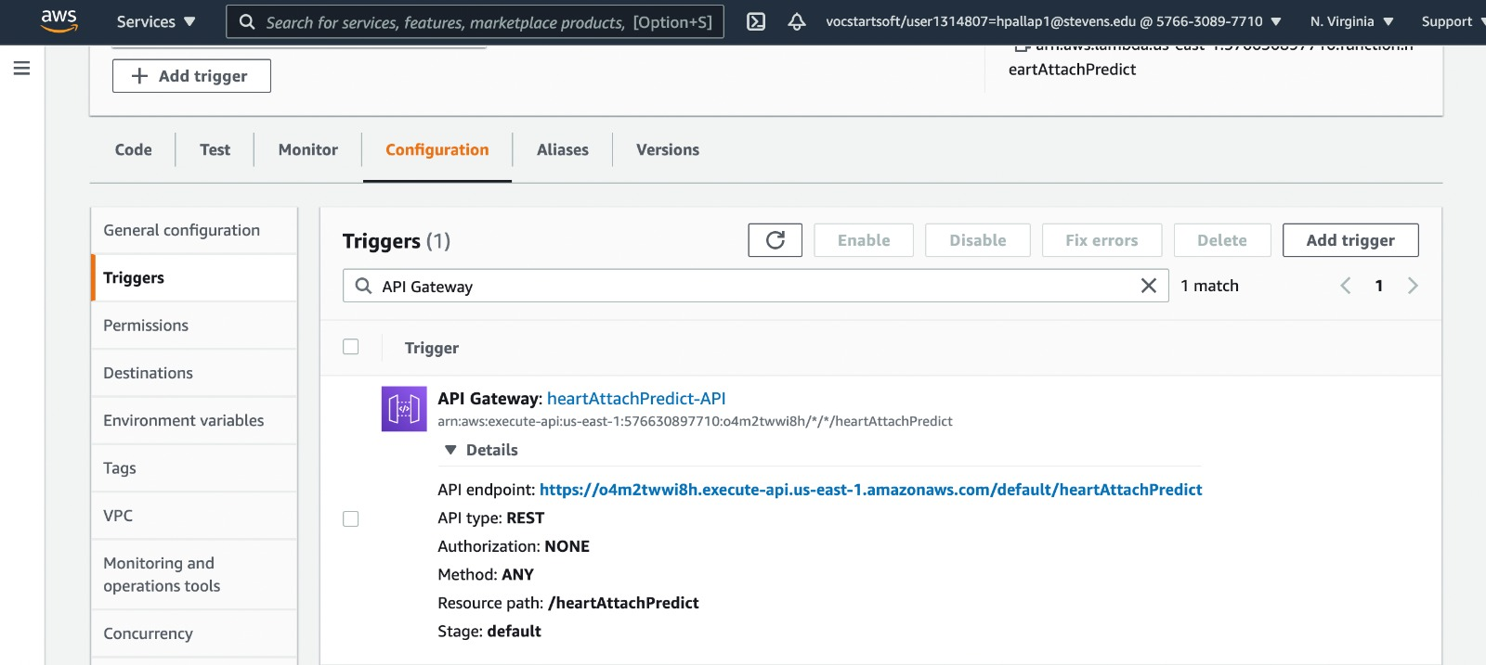

1. **Invoking the lambda function through postman as the method is post by providing the JSON object with the individual data and it will show the response whether the heart attack is predicted or not.**

